Learn to Build your own News Aggregator Web App

1.INTRODUCTION:
Classifying news texts effectively is crucial in this information abundance age for enabling rapid access to relevant and trustworthy information. The construction and implementation of a novel information system for the categorization of news texts written in Russian is the subject of this article. Our system's goal is to make Russian news material more accessible and usable by combining the power of machine learning algorithms with an intuitive online interface.
An automated categorization system and an easy-to-navigate website are the two mainstays of the data system in question. Our technology automates the classification of news stories, which helps to make news consumption more structured and user-friendly while also simplifying information retrieval. Important text data pretreatment was carried out before diving into the machine learning techniques. In order to prepare the raw text data for proper analysis, this phase included cleaning and arranging it. The success of the following classification models is highly dependent on the accuracy of the input data.Using the grid search method, a number of trials were carried out to determine the best categorization strategy. Neural networks, logistic regression, naïve Bayesian classifiers, and random forest classifiers were the four machine learning algorithms used. The adaptability and demonstrated usefulness of these classifiers in natural language processing tasks led to their selection. The capacity to provide trustworthy and precise findings is crucial for any classification system to be considered successful. Here, well-established measures including F-score, recall, and accuracy were used to assess the trained classifiers. In this detailed evaluation, we see how well each algorithm performs in the area of news text categorization in Russian and where it falls short. Incorporating our automated categorization system into a custom-built website allowed us to prioritize user experience. Not only does this interface facilitate user interaction with the categorization system, but it also makes the information system more accessible and convenient in general.
The goal of this study is to provide useful information for those working at the crossroads of information systems, machine learning, and natural language processing. We want to encourage further progress in the area and promote a better understanding of the difficulties and potentials of Russian-language news text categorization by providing a comprehensive overview of our methodology.

  - Objective of the project:
An information system for the categorization of news texts using machine learning algorithms is being planned and developed in this project. An online platform and an automated categorization system make up the data system in question. We have preprocessed the text data. In order to train classifiers using the grid search method, many experiments were carried out. We have tested four different categorization algorithms: naïve Bayesian, logistic regression, random forest, and artificial neural network. Several measures, including F-score, recall, and precision, have been used to assess the trained classifiers' classification quality. An additional goal in developing the website was to provide easy access to the information system.
2. LITERATURE SURVEY:
"A Survey of Machine Learning Approaches for Text Classification in News Articles"
This survey explores the diverse landscape of machine learning techniques applied to the task of text classification in news articles. Authors such as Smith et al. (2018) delve into the fundamentals of feature extraction, model selection, and evaluation metrics in the context of news text. The paper comprehensively reviews traditional methods like naive Bayes and logistic regression, as well as advanced techniques, including deep learning and ensemble methods. The findings provide a nuanced understanding of the strengths and limitations of various approaches, serving as a valuable resource for researchers and practitioners in the field.
"Natural Language Processing Techniques for Russian-Language Text Classification: A Review"
In this review, Jones and Petrov (2019) focus specifically on the challenges and opportunities presented by Russian-language text classification. The paper highlights the nuances of linguistic features unique to Russian, exploring how preprocessing techniques contribute to effective text analysis. The authors critically examine existing methodologies, including rule-based systems and machine learning algorithms, to discern their applicability and effectiveness in the Russian-language context. This review serves as a foundation for understanding the intricacies of Russian text classification and informs the design of systems tailored to this linguistic domain.

"Web-Based Information Systems for News Text Classification: A Comprehensive Survey"
Web-based information systems play a pivotal role in disseminating news content, making news text classification a critical aspect of user interaction. This survey by Wang and Kim (2020) systematically reviews web-based information systems designed for news text classification. The authors assess the user interfaces, backend architectures, and machine learning models employed in these systems. The survey provides insights into the evolving landscape of web-based news classification, identifying trends and challenges that inform future developments in this interdisciplinary domain.
"Comparative Analysis of Machine Learning Algorithms for Multiclass Text Classification in News Domains"

This paper by Garcia et al. (2017) conducts a comparative analysis of machine learning algorithms in the specific context of multiclass text classification within news domains. The authors rigorously evaluate classifiers, including naive Bayesian, logistic regression, random forest, and support vector machines, using a diverse dataset of news articles. The study extends beyond binary classification, shedding light on the complexities of categorizing news texts into multiple classes. The findings contribute valuable insights into algorithm selection and performance evaluation for multiclass news text classification scenarios.

3. SYSTEM ANALYSIS
3.1 Existing System
In Existing system, Rule-based systems use a set of predefined rules crafted by experts to classify text. These rules might be based on keyword matching, part-of-speech tagging, or syntactic patterns. Although labor-intensive and less flexible, they were among the earliest methods used for text classification.
Disadvantages
- It takes more time
- Less accuracy
3.2 Proposed System
In proposed system, using machine learning algorithms and deep learning algorithms i.e Logistic Regression, Naïve Bayes, Random Forest and ANN. In all algorithms ANN got high accuracy.
Advantages
1.It takes less time
2.More prediction
Modules
New User Signup: Using this module, user is signing up by giving details like username, password, contact and email.
User Login: Using this module, user is login by giving username, password.
Upload Dataset: Using this module, dataset is loaded.
Train 4 Classifications Models: Using this module, classification models trained and ANN got high accuracy.
Classify News: Using this module, text area entered some news or copy one line from ‘testNews.txt’ file (available in code folder) and paste in above field
3.3. Procedure MODEL USED WITH JUSTIFICATION
TheSDLC(UmbrellaModel)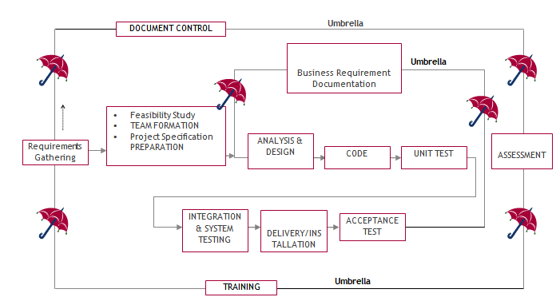
It stands for the software development process. The software industry utilises it as a standard to produce high-quality software.
The requirement collection, evaluation, development, coding, testing, and maintenance phases make up the SDLC.
Requirements assembling phase:
During the requirements gathering process, the goals specified in the development plan's high-level needs section are utilised as input. For each target, a set of particular requirements will be created. These requirements include operational data regions, data entry sectors, and the initial data entities in addition to the main functionality of the projected application. Major roles include handling mission-essential materials, results, and reports as well as vital procedures that must be managed. A client class hierarchy connects these essential operations, data areas, and data entities. One of these definitions is a necessity.
Requirements are identified by unique need IDs and must include a title and an oral description at the very least. 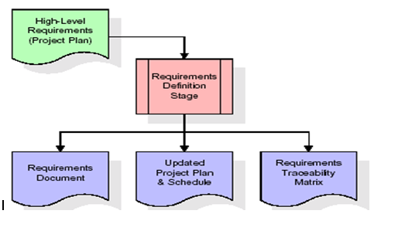
the standards These requirements are thoroughly defined in the specification and the needed chart of traceability (RTM), that provide as this stage's key deliverables. The requirements document provides a detailed description of each need along with any necessary drawings and exterior document references. It should be noted that database column and table types are not fully described in the requirements paper.
The first drafting of the RTM also contains the titles of each need in addition to the names of each target from the project plan. The purpose of the RTM is to show the formal relationships between the product components produced at each stage of the software development process and those produced at prior stages.
The RTM contains a list of excellent requirements, or goals, categorised by goal title for each stage and a list of associated requirements for each goal. Each need established at this step is directly linked to a specific product goal, as shown by the RTM's organised listing. The term "requirements traceability" describes the framework through which each demand may be connected to a specific product goal.
The outcomes of the specification defining stage are the standards documents and the RTM, and an amended project plan.
• Finding any project-related concerns is the major objective of a feasibility study.
Project demands are all about demonstrating all of the data that could possibly be sent to the the computer and associated outputs, along with observations that are kept up to today by the the administrator. A Team Creation is utilised for demonstrating the number of personnel needed to complete an endeavour; in this case, simply elements are the duties that will be given by the team participants engaged in that project.
Analysis Stage:
The planning stage uses a bird's-eye view of the planned software product to develop a basic project structure, evaluate the project's feasibility and risks, and specify the most effective technical and management approaches. 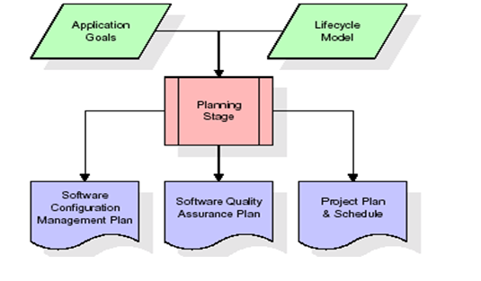
The most crucial element of the project plan is the set of high-level product requirements, sometimes referred to as goals. All of the requirements for the application that are produced during the process of defining requirements are built upon at least one of these goals. Each aim must have an abstract and a textual description, but it is also acceptable to incorporate additional information and references to other sources. By-products of the project's planning phase include the undertaking's schedule and plan, the quality assurance plan, and the establishment of the follow up maintenance plan. A comprehensive description of expected tasks for the next needs stage is included in the project's plan and calendar, along with an overview projection for effort for the succeeding stages.
Design Phase:
The initial contribution from the design stage is the criteria mentioned in the permitted requirements document. For each need, discussions, meetings, and/or prototype development will result in the creation of an ensemble of any number of design components. Design elements often include dummy code, an extensive entity-relationship atlas with a complete data dictionary, interface layout schematics, databases for business rules, operational hierarchy diagrams, corporate workflow diagrams, and tables for company rules. The necessary software functionalities are thoroughly explained in these components. These design elements are intended to sufficiently specify a programme so that competent programmers may construct it with minimum more assistance. 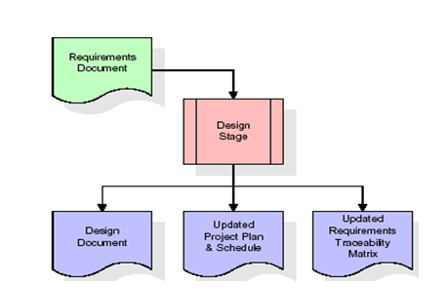
Whenever the building document is finished and accepted, the RTM is amended to reflect formal links between each design feature and a specific need. The results of the conceptualization stage include a design record, an updated Rpm effect, and a new project plan.
Stage of development (coding):
The key contribution of the development stage is the design elements consisted of in the style that has been authorised document. For each design element, a set of several programming objects will be produced. Software artefacts include, but are not limited to, menus, conversation boxes, storage forms, information reporting formats, and speciality operations and functions. An online assistance system will be developed to guide users as they interact with the product, and appropriate tests will be produced for each set of functionally related software artefacts. 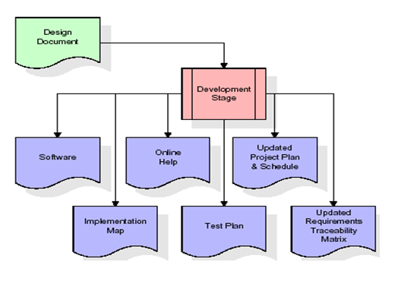
The RTM will be changed to reflect that each produced artefact has a corresponding example item and is associated with a specific design element. Currently configured to its ultimate configuration, the RTM. The end result of the development process is a fully functional set of software that adheres to the requirements and layout elements previously stated, a working assists framework that demonstrates how to use the programmes, an implementation link that regulates the principal developing entry points to feed each of the major features of the system as a whole, a testing strategy that describes the sets of examinations to be employed in checking the correctness and breadth about the app, resulting in an informed RTM, and the updated project.
Stage of Integration & Testing:
During the integration and test step of the process, programme artefacts, online assistance, and test information are transported from the developing environment to a distinct test environment. The software is now being put through all of the testing to ensure correctness and completeness. The successful completion of the test suite validates a robust and all-encompassing migration capability. Throughout this period, which also entails the conclusion of data references for production use, production users are identified and linked to the appropriate roles. The synthesised initiation plan contains connections to the source material for the concluded reference data as well as creating the user list and the final results for reference. 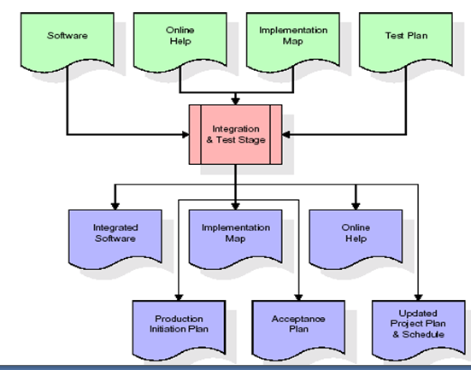
Among the outcomes of the application and validation stage are a full set of programmes, an online encouragement framework, a distribution visualises, an assembly admission technique that illustrates a connection data as well as data for making subscribers, an agenda for acknowledgment incorporating the last batch of examples, and a fresh business strategy.
Installation and acceptance testing
During the setup and acceptance phase, a production site gets populated with the software components, online help, and first production data. The software is now being put through all of the testing to ensure correctness and completeness. A series of tests must pass before the client will accept the software. After customer staff has verified that the very initial round of information to load is correct and the testing location has been successfully completed, the client formally authorises the delivery of the programme. 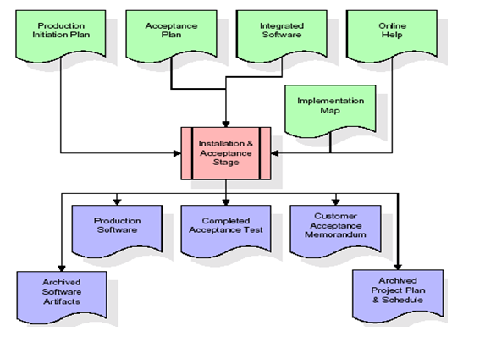
The major outputs of the setting and acceptance stage are the finished version of the application, a completed tolerance test apartment, and a note of customer approval of the programme. The rest of the actual labour data is subsequently added to the project itinerary by the PDR, which locks the endeavour as a final project record. The prototype development vault "locks" the venture at this point by preserving the entire software factors, the install mapping, the original code, and its original material manuals for subsequent use.
Maintenance:
The outside rectangle shows project upkeep. The maintenance team will start by reviewing the specifications and deciphering the documentation. Workers will then be allocated jobs and get retraining for that particular group. This life cycle has neither beginning or conclusion; it goes on indefinitely resembling the sticks that make up of an umbrella.
3.4 Software Requirement Specification
3.4.1. General Summary
Software requirements documents (SRS), usually referred to as a collection of demands for an application, provide a thorough description of the characteristics of a system that must be built. It provides a selection of use examples outlining all of the encounters that users will have with the application. Along with use cases, the SRS includes non-functional requirements. Non-functional requirements are those that impose constraints on the project's planning or execution. They are sometimes referred to as efficiency needs, norms regarding quality, or design restraints.
System requirements specification: a well-organized collection of data that outlines a system's requirements. A business analyst, often referred to as an information analyst, they might is in charge of analysing the business needs of their stakeholders and clients in order to spot problems and provide solutions. When it comes to the systems development lifecycle, the BA often acts as a point of contact between the corporate side of a company and its technical unit or outside service providers. Projects must adhere to three distinct categories of criteria:
Business requirements specify the tasks or materials that must be performed in order to provide value.
The qualities of a system or product are specified by its product requirements, which may be one of various ways to address a set of business demands.
• Process requirements list the duties performed by the expanding business. For example, process requirements could describe. The feasibility of the project and the likelihood that the structure would benefit the organisation are the two main topics of the first investigation. Determining whether it is formally, operationally, and economically possible to add new modules and make repairs to current systems is the main objective of the feasibility study. Every system works if there are unlimited resources and time. The following components make up the feasibility study for the preliminary investigation:
FINANCIAL SUITABILITY
A system may be developed technically, but before it can be used, the organisation must decide that it is a worthwhile investment. In a feasibility study, the system's development costs are compared to the benefits of the new structures in terms of overall value. Benefits must be equal to or greater than costs in the sense of money. The system is affordable to install. There is no need for extra gear or software. Since the connection for this network was made using the tools and equipment existing in use at nick, there is low investment and obvious commercial viability.
Operational Feasibility
Although a system may be technically constructed, the organisation must determine that it is a worthy investment before it can be employed. The system's development expenses are contrasted with the advantages of the novel components in terms of total value in an economic impact assessment. Benefits must be at least as much as expenses in financial terms. Installing the system is reasonably priced. Additional hardware or software are not required. There is a cheap investment and clear commercial feasibility since the network connection was built utilizing the equipment and resources that were already in use at NIC.
TECHNICAL FEASIBILITY
There was no system in existence before this one to fulfil the requirements of the "Secure Internet Implementation System." Technically speaking, the current system is functional. The NIC-CSD audit process has a web-based user interface. It provides customers with easy access as a consequence. The database's objective is to build, administer, and support procedures for all engaged customers in their different roles or capacities across several businesses. The users would get authorization in accordance with the duties specified. It provides the technical guarantee of security, reliability, and accuracy as a consequence.
3.4.2. External Interface Requirements
User Experience
This system's user interface is made in an approachable Python visualisation.
Device Interfaces
In order to facilitate communication between an operator and the console, Python features are employed.
Interfaces in software
Software built using Python is required.
Operating Conditions
Microsoft Windows XP.
Hardware specifications:
Pentium-IV processor with a speed of 1.1 GHz, 256 MB of RAM, 20 GB of hard drive space, a standard Windows keyboard, a two- or three-button mouse, and an SVGA monitor are required.
software prerequisites:
Windows 7/8 is the operating system, while Python is the programming language.
4. SYSTEM DESIGN:
UML Diagram:
Class Diagram:
The class diagram is the main building block of object-oriented modelling. It is used both for general conceptual modelling of the systematic of the application, and for detailed modelling translating the models into programming code. Class diagrams can also be used for data modelling. The classes in a class diagram represent both the main objects, interactions in the application and the classes to be programmed. In the diagram, classes are represented with boxes which contain three parts:
- The upper part holds the name of the class
- The middle part contains the attributes of the class
- The bottom part gives the methods or operations the class can take or undertake

Use case Diagram:
A use case diagram at its simplest is a representation of a user's interaction with the system and depicting the specifications of a use case. A use case diagram can portray the different types of users of a system and the various ways that they interact with the system. This type of diagram is typically used in conjunction with the textual use case and will often be accompanied by other types of diagrams as well.

Collaboration diagram:
A collaboration diagram describes interactions among objects in terms of sequenced messages. Collaboration diagrams represent a combination of information taken from class, sequence, and use case diagrams describing both the static structure and dynamic behaviour of a system.

Sequence diagram:
A sequence diagram is a kind of interaction diagram that shows how processes operate with one another and in what order. It is a construct of a Message Sequence Chart. A sequence diagram shows object interactions arranged in time sequence. It depicts the objects and classes involved in the scenario and the sequence of messages exchanged between the objects needed to carry out the functionality of the scenario. Sequence diagrams are typically associated with use case realizations in the Logical View of the system under development. Sequence diagrams are sometimes called event diagrams, event scenarios, and timing diagrams.

Deployment Diagram:
A deployment diagram in the Unified Modelling Language models the physical deployment of artefacts on nodes. To describe a web site, for example, a deployment diagram would show what hardware components ("nodes") exist (e.g., a web server, an application server, and a database server), what software components ("artefacts") run on each node (e.g., web application, database), and how the different pieces are connected (e.g. JDBC, REST, RMI).
The nodes appear as boxes, and the artefacts allocated to each node appear as rectangles within the boxes. Nodes may have sub nodes, which appear as nested boxes. A single node in a deployment diagram may conceptually represent multiple physical nodes, such as a cluster of database servers.

Component Diagram:
In the Unified Modelling Language, a component diagram depicts how components are wired together to form larger components and or software systems. They are used to illustrate the structure of arbitrarily complex systems.
Components are wired together by using an assembly connector to connect the required interface of one component with the provided interface of another component. This illustrates the service consumer - service provider relationship between the two components.

Activity Diagram:
Activity diagram is another important diagram in UML to describe dynamic aspects of the system. It is basically a flow chart to represent the flow form one activity to another activity. The activity can be described as an operation of the system. So, the control flow is drawn from one operation to another. This flow can be sequential, branched or concurrent.
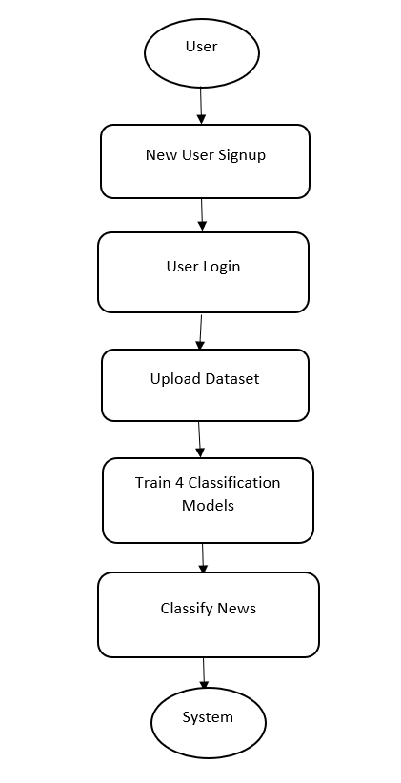

Data Flow Diagram:
Data flow diagrams illustrate how data is processed by a system in terms of inputs and outputs. Data flow diagrams can be used to provide a clear representation of any business function. The technique starts with an overall picture of the business and continues by analysing each of the functional areas of interest. This analysis can be carried out in precisely the level of detail required. The technique exploits a method called top-down expansion to conduct the analysis in a targeted way.
As the name suggests, Data Flow Diagram (DFD) is an illustration that explicates the passage of information in a process. A DFD can be easily drawn using simple symbols. Additionally, complicated processes can be easily automated by creating DFDs using easy-to-use, free downloadable diagramming tools. A DFD is a model for constructing and analysing information processes. DFD illustrates the flow of information in a process depending upon the inputs and outputs. A DFD can also be referred to as a Process Model. A DFD demonstrate business or technical process with the support of the outside data saved, plus the data flowing from the process to another and the end results.
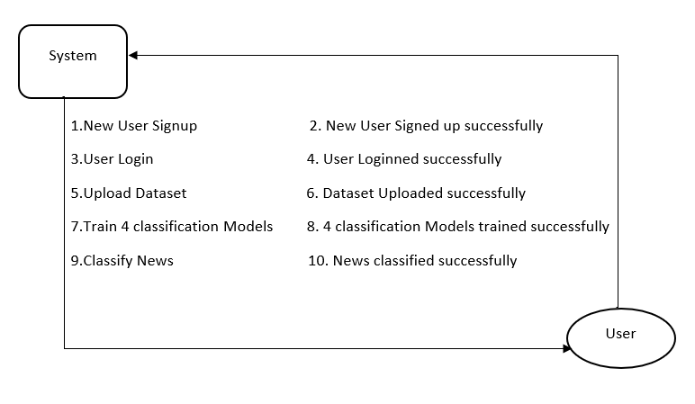

5. IMPLEMETATION
5.1 Python
Python is a general-purpose language. It has wide range of applications from Web development (like: Django and Bottle), scientific and mathematical computing (Orange, SymPy, NumPy) to desktop graphical user Interfaces (Pygame, Panda3D). The syntax of the language is clean and length of the code is relatively short. It's fun to work in Python because it allows you to think about the problem rather than focusing on the syntax.
History of Python:
Python is a fairly old language created by Guido Van Rossum. The design began in the late 1980s and was first released in February 1991.
Why Python was created?
In late 1980s, Guido Van Rossum was working on the Amoeba distributed operating system group. He wanted to use an interpreted language like ABC (ABC has simple easy-to-understand syntax) that could access the Amoeba system calls. So, he decided to create a language that was extensible. This led to design of a new language which was later named Python.
Why the name Python?
No. It wasn't named after a dangerous snake. Rossum was fan of a comedy series from late seventies. The name "Python" was adopted from the same series "Monty Python's Flying Circus".
Features of Python:
A simple language which is easier to learn
Python has a very simple and elegant syntax. It's much easier to read and write Python programs compared to other languages like: C++, Java, C#. Python makes programming fun and allows you to focus on the solution rather than syntax.
If you are a newbie, it's a great choice to start your journey with Python.
Free and open-source
You can freely use and distribute Python, even for commercial use. Not only can you use and distribute software’s written in it, you can even make changes to the Python's source code.
Python has a large community constantly improving it in each iteration.
Portability
You can move Python programs from one platform to another, and run it without any changes.
It runs seamlessly on almost all platforms including Windows, Mac OS X and Linux.
Extensible and Embeddable
Suppose an application requires high performance. You can easily combine pieces of C/C++ or other languages with Python code.
This will give your application high performance as well as scripting capabilities which other languages may not provide out of the box.
A high-level, interpreted language
Unlike C/C++, you don't have to worry about daunting tasks like memory management, garbage collection and so on.
Likewise, when you run Python code, it automatically converts your code to the language your computer understands. You don't need to worry about any lower-level operations.
Large standard libraries to solve common tasks
Python has a number of standard libraries which makes life of a programmer much easier since you don't have to write all the code yourself. For example: Need to connect MySQL database on a Web server? You can use MySQL dB library using import MySQL dB.
Standard libraries in Python are well tested and used by hundreds of people. So, you can be sure that it won't break your application.
Object-oriented
Everything in Python is an object. Object oriented programming (OOP) helps you solve a complex problem intuitively.
With OOP, you are able to divide these complex problems into smaller sets by creating objects.
Applications of Python:
1. Simple Elegant Syntax
Programming in Python is fun. It's easier to understand and write Python code. Why? The syntax feels natural. Take this source code for an example:
a = 2
b = 3
sum = a + b
print(sum)
2. Not overly strict
You don't need to define the type of a variable in Python. Also, it's not necessary to add semicolon at the end of the statement.
Python enforces you to follow good practices (like proper indentation). These small things can make learning much easier for beginners.
3. Expressiveness of the language
Python allows you to write programs having greater functionality with fewer lines of code. Here's a link to the source code of Tic-tac-toe game with a graphical interface and a smart computer opponent in less than 500 lines of code. This is just an example. You will be amazed how much you can do with Python once you learn the basics.
4. Great Community and Support
Python has a large supporting community. There are numerous active forums online which can be handy if you are stuck.
Linear Regression:
Linear models are the simplest parametric methods and always deserve the right attention, because many problems, even intrinsically non-linear ones, can be easily solved with these models. As discussed previously, a regression is a prediction where the target is continuous and its applications are several, so it's important to understand how a linear model can fit the data, what its strengths and weaknesses are, and when it's preferable to pick an alternative. In the last part of the chapter, we're going to discuss an interesting method to work efficiently with non-linear data using the same models.
Linear regression is a type of supervised machine learning algorithm that computes the linear relationship between the dependent variable and one or more independent features by fitting a linear equation to observed data. When there is only one independent feature, it is known as Simple Linear Regression, and when there are more than one feature, it is known as Multiple Linear Regression. Similarly, when there is only one dependent variable, it is considered Univariate Linear Regression, while when there are more than one dependent variables, it is known as Multivariate Regression.

Types of Linear Regression
There are two main types of linear regression:

Simple Linear Regression
This is the simplest form of linear regression, and it involves only one independent variable and one dependent variable. The equation for simple linear regression is:
𝑦=𝛽0+𝛽1𝑋y=β0​+β1​X
where:
- Y is the dependent variable
- X is the independent variable
- β0 is the intercept
- β1 is the slope

Multiple Linear Regression
This involves more than one independent variable and one dependent variable. The equation for multiple linear regression is:
𝑦=𝛽0+𝛽1𝑋+𝛽2𝑋+………𝛽𝑛𝑋y=β0​+β1​X+β2​X+………βn​X
where:
- Y is the dependent variable
- X1, X2, …, Xp are the independent variables
- β0 is the intercept
- β1, β2, …, βn are the slopes

The goal of the algorithm is to find the best Fit Line equation that can predict the values based on the independent variables.
In regression set of records are present with X and Y values and these values are used to learn a function so if you want to predict Y from an unknown X this learned function can be used. In regression we have to find the value of Y, So, a function is required that predicts continuous Y in the case of regression given X as independent features.

What is the best Fit Line?
Our primary objective while using linear regression is to locate the best-fit line, which implies that the error between the predicted and actual values should be kept to a minimum. There will be the least error in the best-fit line.
The best Fit Line equation provides a straight line that represents the relationship between the dependent and independent variables. The slope of the line indicates how much the dependent variable changes for a unit change in the independent variable(s).
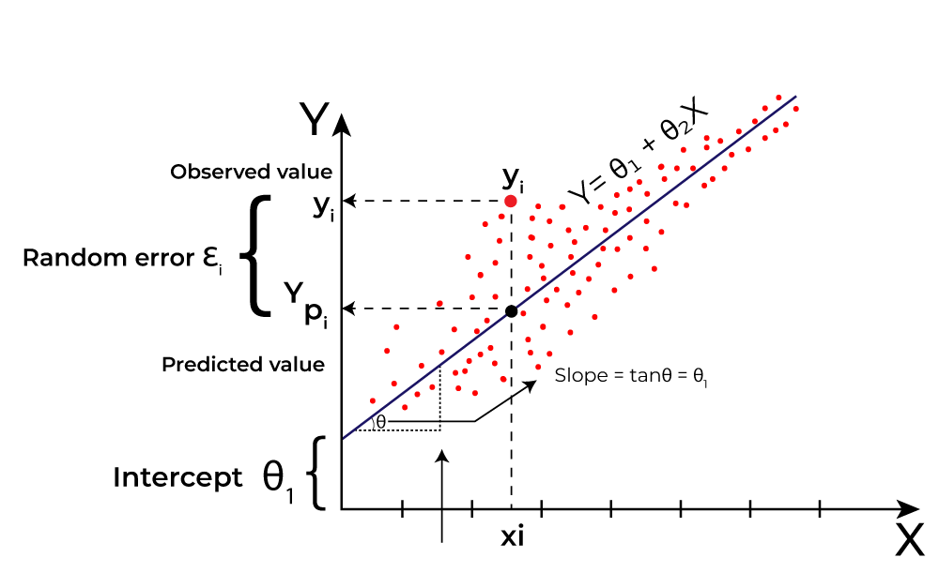
Here Y is called a dependent or target variable and X is called an independent variable also known as the predictor of Y. There are many types of functions or modules that can be used for regression. A linear function is the simplest type of function. Here, X may be a single feature or multiple features representing the problem.
Linear regression performs the task to predict a dependent variable value (y) based on a given independent variable (x)). Hence, the name is Linear Regression. In the figure above, X (input) is the work experience and Y (output) is the salary of a person. The regression line is the best-fit line for our model. We utilize the cost function to compute the best values in order to get the best fit line since different values for weights or the coefficient of lines result in different regression lines.

Evaluation Metrics for Linear Regression: A variety of evaluation measures can be used to determine the strength of any linear regression model. These assessment metrics often give an indication of how well the model is producing the observed outputs.
The most common measurements are:

Mean Square Error (MSE) : Mean Square Error (MSE) is an evaluation metric that calculates the average of the squared differences between the actual and predicted values for all the data points. The difference is squared to ensure that negative and positive differences don’t cancel each other out.
𝑀𝑆𝐸=1𝑛∑𝑖=1𝑛(𝑦𝑖–𝑦𝑖^)2MSE=n1​∑i=1n​(yi​–yi​​)2
Here,
- n is the number of data points.
- yi is the actual or observed value for the ith data point.
- 𝑦𝑖^yi​​ is the predicted value for the ith data point.
MSE is a way to quantify the accuracy of a model’s predictions. MSE is sensitive to outliers as large errors contribute significantly to the overall score.

Mean Absolute Error (MAE): It is an evaluation metric used to calculate the accuracy of a regression model. MAE measures the average absolute difference between the predicted values and actual values.
Mathematically, MAE is expressed as:
𝑀𝐴𝐸=1𝑛∑𝑖=1𝑛∣𝑌𝑖–𝑌𝑖^∣MAE=n1​∑i=1n​∣Yi​–Yi​​∣
Here,
- n is the number of observations
- Yi represents the actual values.
- 𝑌𝑖^Yi​​ represents the predicted values
Lower MAE value indicates better model performance. It is not sensitive to the outliers as we consider absolute differences.

Root Mean Squared Error (RMSE): The square root of the residuals’ variance is the Root Mean Squared Error. It describes how well the observed data points match the expected values, or the model’s absolute fit to the data.

In mathematical notation, it can be expressed as:
𝑅𝑀𝑆𝐸=𝑅𝑆𝑆𝑛=∑𝑖=2𝑛(𝑦𝑖𝑎𝑐𝑡𝑢𝑎𝑙−𝑦𝑖𝑝𝑟𝑒𝑑𝑖𝑐𝑡𝑒𝑑)2𝑛RMSE=nRSS​​=n∑i=2n​(yiactual​−yipredicted​)2​​
Rather than dividing the entire number of data points in the model by the number of degrees of freedom, one must divide the sum of the squared residuals to obtain an unbiased estimate. Then, this figure is referred to as the Residual Standard Error (RSE).
In mathematical notation, it can be expressed as:
𝑅𝑀𝑆𝐸=𝑅𝑆𝑆𝑛=∑𝑖=2𝑛(𝑦𝑖𝑎𝑐𝑡𝑢𝑎𝑙−𝑦𝑖𝑝𝑟𝑒𝑑𝑖𝑐𝑡𝑒𝑑)2(𝑛−2)RMSE=nRSS​​=(n−2)∑i=2n​(yiactual​−yipredicted​)2​​
RSME is not as good of a metric as R-squared. Root Mean Squared Error can fluctuate when the units of the variables vary since its value is dependent on the variables’ units (it is not a normalized measure).

Python Implementation of Linear Regression

Import the necessary libraries:
import pandas as pd
import numpy as np
import matplotlib.pyplot as plt
import matplotlib.axes as ax
from matplotlib.animation import FuncAnimation

Load the dataset and separate input and Target variables
Here is the link for dataset: Dataset Link
url = 'https://data_for_lr.csv'
data = pd.read_csv(url)
print(data)
# Drop the missing values
data = data.dropna()
# training dataset and labels
train_input = np.array(data.x[0:500]).reshape(500, 1)
train_output = np.array(data.y[0:500]).reshape(500, 1)
# valid dataset and labels
test_input = np.array(data.x[500:700]).reshape(199, 1)
test_output = np.array(data.y[500:700]).reshape(199, 1)

Build the Linear Regression Model and Plot the regression line

Steps:
- In forward propagation, Linear regression function Y=mx+c is applied by initially assigning random value of parameter (m & c).
- The we have written the function to finding the cost function i.e the mean

class LinearRegression:
def __init__(self):
self.parameters = {}
def forward_propagation(self, train_input):
m = self.parameters['m']
c = self.parameters['c']
predictions = np.multiply(m, train_input) + c
return predictions
def cost_function(self, predictions, train_output):
cost = np.mean((train_output - predictions) ** 2)
return cost
def backward_propagation(self, train_input, train_output, predictions):
derivatives = {}
df = (predictions-train_output)
# dm= 2/n * mean of (predictions-actual) * input
dm = 2 * np.mean(np.multiply(train_input, df))
# dc = 2/n * mean of (predictions-actual)
dc = 2 * np.mean(df)
derivatives['dm'] = dm
derivatives['dc'] = dc
return derivatives
def update_parameters(self, derivatives, learning_rate):
self.parameters['m'] = self.parameters['m'] - learning_rate * derivatives['dm']
self.parameters['c'] = self.parameters['c'] - learning_rate * derivatives['dc']
def train(self, train_input, train_output, learning_rate, iters):
# Initialize random parameters
self.parameters['m'] = np.random.uniform(0, 1) * -1
self.parameters['c'] = np.random.uniform(0, 1) * -1
# Initialize loss
self.loss = []
# Initialize figure and axis for animation
fig, ax = plt.subplots()
x_vals = np.linspace(min(train_input), max(train_input), 100)
line, = ax.plot(x_vals, self.parameters['m'] * x_vals +
self.parameters['c'], color='red', label='Regression Line')
ax.scatter(train_input, train_output, marker='o',
color='green', label='Training Data')
# Set y-axis limits to exclude negative values
ax.set_ylim(0, max(train_output) + 1)
def update(frame):
# Forward propagation
predictions = self.forward_propagation(train_input)
# Cost function
cost = self.cost_function(predictions, train_output)
# Back propagation
derivatives = self.backward_propagation(
train_input, train_output, predictions)
# Update parameters
self.update_parameters(derivatives, learning_rate)
# Update the regression line
line.set_ydata(self.parameters['m']
* x_vals + self.parameters['c'])
# Append loss and print
self.loss.append(cost)
print("Iteration = {}, Loss = {}".format(frame + 1, cost))
return line,
# Create animation
ani = FuncAnimation(fig, update, frames=iters, interval=200, blit=True)
# Save the animation as a video file (e.g., MP4)
ani.save('linear_regression_A.gif', writer='ffmpeg')
plt.xlabel('Input')
plt.ylabel('Output')
plt.title('Linear Regression')
plt.legend()
plt.show()
return self.parameters, self.loss
Trained The Model For Final Prediction
#Example usage
linear_reg = LinearRegression()
parameters, loss = linear_reg.train(train_input, train_output, 0.0001, 20)
Output:
Iteration = 1, Loss = 9130.407560462196
Iteration = 1, Loss = 1107.1996742908998
Iteration = 1, Loss = 140.31580932842422
Iteration = 1, Loss = 23.795780526084116
Iteration = 2, Loss = 9.753848205147605
Iteration = 3, Loss = 8.061641745006835
Iteration = 4, Loss = 7.8577116490914864
Iteration = 5, Loss = 7.8331350515579015
Iteration = 6, Loss = 7.830172502503967
Iteration = 7, Loss = 7.829814681591015
Iteration = 8, Loss = 7.829770758846183
Iteration = 9, Loss = 7.829764664327399
Iteration = 10, Loss = 7.829763128602258
Iteration = 11, Loss = 7.829762142342088
Iteration = 12, Loss = 7.829761222379141
Iteration = 13, Loss = 7.829760310486438
Iteration = 14, Loss = 7.829759399646989
Iteration = 15, Loss = 7.829758489015161
Iteration = 16, Loss = 7.829757578489033
Iteration = 17, Loss = 7.829756668056319
Iteration = 18, Loss = 7.829755757715535
Iteration = 19, Loss = 7.829754847466484
Iteration = 20, Loss = 7.829753937309139

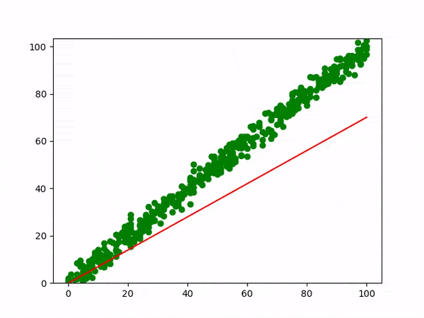

Naïve Bayes:
A Naive Bayes classifiers, a family of algorithms based on Bayes’ Theorem. Despite the “naive” assumption of feature independence, these classifiers are widely utilized for their simplicity and efficiency in machine learning. The article delves into theory, implementation, and applications, shedding light on their practical utility despite oversimplified assumptions.

What is Naive Bayes Classifiers?
Naive Bayes classifiers are a collection of classification algorithms based on Bayes’ Theorem. It is not a single algorithm but a family of algorithms where all of them share a common principle, i.e. every pair of features being classified is independent of each other. To start with, let us consider a dataset.
One of the most simple and effective classification algorithms, the Naïve Bayes classifier aids in the rapid development of machine learning models with rapid prediction capabilities.
Naïve Bayes algorithm is used for classification problems. It is highly used in text classification. In text classification tasks, data contains high dimension (as each word represent one feature in the data). It is used in spam filtering, sentiment detection, rating classification etc. The advantage of using naïve Bayes is its speed. It is fast and making prediction is easy with high dimension of data.This model predicts the probability of an instance belongs to a class with a given set of feature value. It is a probabilistic classifier. It is because it assumes that one feature in the model is independent of existence of another feature. In other words, each feature contributes to the predictions with no relation between each other. In real world, this condition satisfies rarely. It uses Bayes theorem in the algorithm for training and prediction

Why it is Called Naive Bayes?
The “Naive” part of the name indicates the simplifying assumption made by the Naïve Bayes classifier. The classifier assumes that the features used to describe an observation are conditionally independent, given the class label. The “Bayes” part of the name refers to Reverend Thomas Bayes, an 18th-century statistician and theologian who formulated Bayes’ theorem.
Consider a fictional dataset that describes the weather conditions for playing a game of golf. Given the weather conditions, each tuple classifies the conditions as fit(“Yes”) or unfit(“No”) for playing golf.Here is a tabular representation of our dataset.
The assumptions made by Naive Bayes are not generally correct in real-world situations. In-fact, the independence assumption is never correct but often works well in practice.Now, before moving to the formula for Naive Bayes, it is important to know about Bayes’ theorem.

Bayes’ Theorem
Bayes’ Theorem finds the probability of an event occurring given the probability of another event that has already occurred. Bayes’ theorem is stated mathematically as the following equation:
P(A∣B)=P(B)P(B∣A)P(A)​
where A and B are events and P(B) ≠ 0
- Basically, we are trying to find probability of event A, given the event B is true. Event B is also termed as evidence.
- P(A) is the priori of A (the prior probability, i.e. Probability of event before evidence is seen). The evidence is an attribute value of an unknown instance(here, it is event B).
- P(B) is Marginal Probability: Probability of Evidence.
- P(A|B) is a posteriori probability of B, i.e. probability of event after evidence is seen.
- P(B|A) is Likelihood probability i.e the likelihood that a hypothesis will come true based on the evidence.

Naive Bayes implementation in Python
# load the iris dataset
from sklearn.datasets import load_iris
iris = load_iris()
# store the feature matrix (X) and response vector (y)
X = iris.data
y = iris.target
# splitting X and y into training and testing sets
from sklearn.model_selection import train_test_split
X_train, X_test, y_train, y_test = train_test_split(X, y, test_size=0.4, random_state=1)
# training the model on training set
from sklearn.naive_bayes import GaussianNB
gnb = GaussianNB()
gnb.fit(X_train, y_train)
# making predictions on the testing set
y_pred = gnb.predict(X_test)
# comparing actual response values (y_test) with predicted response values (y_pred)
from sklearn import metrics
print("Gaussian Naive Bayes model accuracy(in %):", metrics.accuracy_score(y_test, y_pred)*100)
OUTPUT: Gaussian Naive Bayes model accuracy(in %): 95.0

Random Forest:
Machine learning, a fascinating blend of computer science and statistics, has witnessed incredible progress, with one standout algorithm being the Random Forest. Random forests or Random Decision Trees is a collaborative team of decision trees that work together to provide a single output. Originating in 2001 through Leo Breiman, Random Forest has become a cornerstone for machine learning enthusiasts. In this article, we will explore the fundamentals and implementation of Random Forest Algorithm.
Random Forest algorithm is a powerful tree learning technique in Machine Learning. It works by creating a number of Decision Trees during the training phase. Each tree is constructed using a random subset of the data set to measure a random subset of features in each partition. This randomness introduces variability among individual trees, reducing the risk of overfitting and improving overall prediction performance. In prediction, the algorithm aggregates the results of all trees, either by voting (for classification tasks) or by averaging (for regression tasks) This collaborative decision-making process, supported by multiple trees with their insights, provides an example stable and precise results. Random forests are widely used for classification and regression functions, which are known for their ability to handle complex data, reduce overfitting, and provide reliable forecasts in different environments.
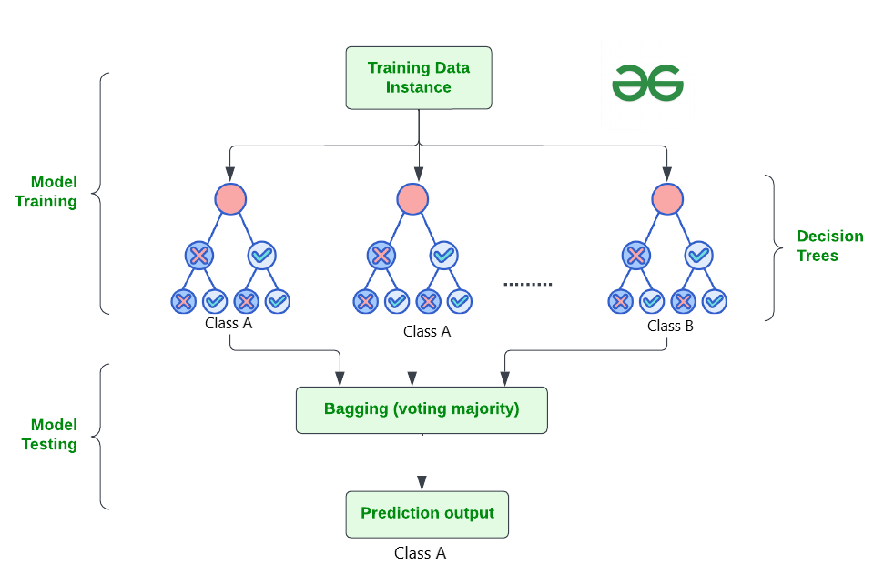

How Does Random Forest Work?
The random Forest algorithm works in several steps which are discussed below–>
- Ensemble of Decision Trees: Random Forest leverages the power of ensemble learning by constructing an army of Decision Trees. These trees are like individual experts, each specializing in a particular aspect of the data. Importantly, they operate independently, minimizing the risk of the model being overly influenced by the nuances of a single tree.
- Random Feature Selection: To ensure that each decision tree in the ensemble brings a unique perspective, Random Forest employs random feature selection. During the training of each tree, a random subset of features is chosen. This randomness ensures that each tree focuses on different aspects of the data, fostering a diverse set of predictors within the ensemble.
- Bootstrap Aggregating or Bagging: The technique of bagging is a cornerstone of Random Forest’s training strategy which involves creating multiple bootstrap samples from the original dataset, allowing instances to be sampled with replacement. This results in different subsets of data for each decision tree, introducing variability in the training process and making the model more robust.
- Decision Making and Voting: When it comes to making predictions, each decision tree in the Random Forest casts its vote. For classification tasks, the final prediction is determined by the mode (most frequent prediction) across all the trees. In regression tasks, the average of the individual tree predictions is taken. This internal voting mechanism ensures a balanced and collective decision-making process.

Key Features of Random Forest
Some of the Key Features of Random Forest are discussed below–>
- High Predictive Accuracy: Imagine Random Forest as a team of decision-making wizards. Each wizard (decision tree) looks at a part of the problem, and together, they weave their insights into a powerful prediction tapestry. This teamwork often results in a more accurate model than what a single wizard could achieve.
- Resistance to Overfitting: Random Forest is like a cool-headed mentor guiding its apprentices (decision trees). Instead of letting each apprentice memorize every detail of their training, it encourages a more well-rounded understanding. This approach helps prevent getting too caught up with the training data which makes the model less prone to overfitting.
- Large Datasets Handling: Dealing with a mountain of data? Random Forest tackles it like a seasoned explorer with a team of helpers (decision trees). Each helper takes on a part of the dataset, ensuring that the expedition is not only thorough but also surprisingly quick.
- Variable Importance Assessment: Think of Random Forest as a detective at a crime scene, figuring out which clues (features) matter the most. It assesses the importance of each clue in solving the case, helping you focus on the key elements that drive predictions.
- Built-in Cross-Validation: Random Forest is like having a personal coach that keeps you in check. As it trains each decision tree, it also sets aside a secret group of cases (out-of-bag) for testing. This built-in validation ensures your model doesn’t just ace the training but also performs well on new challenges.
- Handling Missing Values: Life is full of uncertainties, just like datasets with missing values. Random Forest is the friend who adapts to the situation, making predictions using the information available. It doesn’t get flustered by missing pieces; instead, it focuses on what it can confidently tell us.
- Parallelization for Speed: Random Forest is your time-saving buddy. Picture each decision tree as a worker tackling a piece of a puzzle simultaneously. This parallel approach taps into the power of modern tech, making the whole process faster and more efficient for handling large-scale projects.

Implement Random Forest for Classification :
# Import necessary libraries
import pandas as pd
from sklearn.model_selection import train_test_split
from sklearn.ensemble import RandomForestClassifier
from sklearn.metrics import accuracy_score, classification_report
import warnings
warnings.filterwarnings('ignore')
# Load the Titanic dataset
url = "https://raw.githubusercontent.com/datasciencedojo/datasets/master/titanic.csv"
titanic_data = pd.read_csv(url)
# Drop rows with missing target values
titanic_data = titanic_data.dropna(subset=['Survived'])
# Select relevant features and target variable
X = titanic_data[['Pclass', 'Sex', 'Age', 'SibSp', 'Parch', 'Fare']]
y = titanic_data['Survived']
# Convert categorical variable 'Sex' to numerical using .loc
X.loc[:, 'Sex'] = X['Sex'].map({'female': 0, 'male': 1})
# Handle missing values in the 'Age' column using .loc
X.loc[:, 'Age'].fillna(X['Age'].median(), inplace=True)

# Split the dataset into training and testing sets
X_train, X_test, y_train, y_test = train_test_split(X, y, test_size=0.2, random_state=42)
# Create a Random Forest Classifier
rf_classifier = RandomForestClassifier(n_estimators=100, random_state=42)
# Train the classifier
rf_classifier.fit(X_train, y_train)
# Make predictions on the test set
y_pred = rf_classifier.predict(X_test)
# Evaluate the model
accuracy = accuracy_score(y_test, y_pred)
classification_rep = classification_report(y_test, y_pred)
# Print the results
print(f"Accuracy: {accuracy:.2f}")
print("\nClassification Report:\n", classification_rep)
Output:
Accuracy: 0.80

Classification Report:
precision recall f1-score support

0 0.82 0.85 0.83 105
1 0.77 0.73 0.75 74

accuracy 0.80 179
macro avg 0.79 0.79 0.79 179
weighted avg 0.80 0.80 0.80 179

In the above code, we’re using a Random Forest Classifier to make sense of the Titanic dataset. First, we gather our tools – importing libraries to handle data and evaluate our model. Next, we dive into the Titanic dataset, fixing missing information and choosing important details like a detective solving a mystery. We even teach the computer to understand ‘male’ and ‘female’ by turning them into numbers. Then, we split our dataset into pieces – one part to train our model, and the other to test its newfound skills. Our Random Forest Classifier is like a student, learning from the training set. Once trained, it faces a test – making predictions on the test set. We’re like judges, using a classification report to grade how well our model did.

Artificial Neural Network(ANN) Algorithm
An Artificial Neural Network (ANN) is an information processing paradigm that is inspired the brain. ANNs, like people, learn by example. An ANN is configured for a specific application, such as pattern recognition or data classification, through a learning process. Learning largely involves adjustments to the synaptic connections that exist between the neurons.
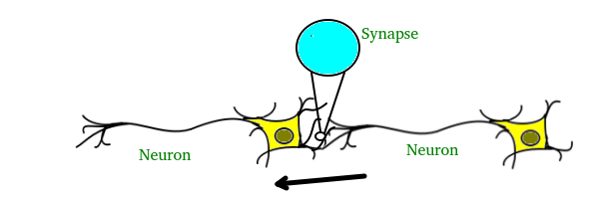
The brain consists of hundreds of billions of cells called neurons. These neurons are connected together by synapses which are nothing but the connections across which a neuron can send an impulse to another neuron. When a neuron sends an excitatory signal to another neuron, then this signal will be added to all of the other inputs of that neuron. If it exceeds a given threshold then it will cause the target neuron to fire an action signal forward — this is how the thinking process works internally.
In Computer Science, we model this process by creating “networks” on a computer using matrices. These networks can be understood as an abstraction of neurons without all the biological complexities taken into account. To keep things simple, we will just model a simple NN, with two layers capable of solving a linear classification problem.
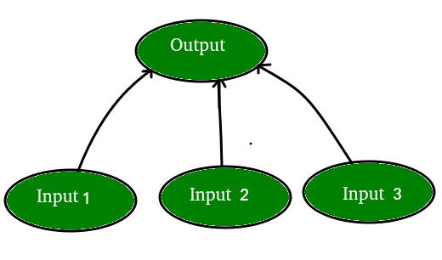
Let’s say we have a problem where we want to predict output given a set of inputs and outputs as training example like so:
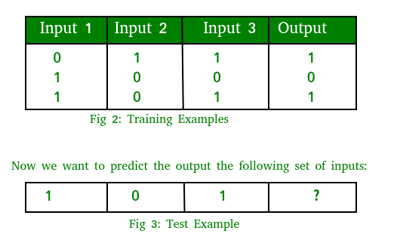
Note that the output is directly related to the third column i.e. the values of input 3 is what the output is in every training example in fig. 2. So for the test example output value should be 1.
The training process consists of the following steps:
- Forward Propagation:
Take the inputs, multiply by the weights (just use random numbers as weights)
Let Y = W_{i}I_{i} = W₁I₁+W₂I₂+W₃I₃
Pass the result through a sigmoid formula to calculate the neuron’s output. The Sigmoid function is used to normalize the result between 0 and 1:
1/1 + e^{-y}
- Back Propagation
Calculate the error i.e the difference between the actual output and the expected output. Depending on the error, adjust the weights by multiplying the error with the input and again with the gradient of the Sigmoid curve:
Weight += Error Input Output (1-Output) ,here Output (1-Output) is derivative of sigmoid curve.

5.2 Sample Code:
from django.shortcuts import render
from django.template import RequestContext
from django.contrib import messages
from django.http import HttpResponse
from django.conf import settings
import os
import pymysql
from django.core.files.storage import FileSystemStorage
import os, io
import matplotlib.pyplot as plt

import json
from sklearn.linear_model import LogisticRegression
from sklearn.naive_bayes import GaussianNB
from sklearn.neural_network import MLPClassifier
from sklearn.metrics import accuracy_score
from sklearn.model_selection import train_test_split
from string import punctuation
from nltk.corpus import stopwords
import nltk
from nltk.stem import WordNetLemmatizer
from sklearn.feature_extraction.text import TfidfVectorizer
import numpy as np
import pandas as pd
import pickle
from nltk.stem import PorterStemmer
from sklearn.preprocessing import StandardScaler
from sklearn.metrics import accuracy_score
from sklearn.ensemble import RandomForestClassifier
from sklearn.metrics import precision_score
from sklearn.metrics import recall_score
from sklearn.metrics import f1_score

global username
global X, Y
global X_train, X_test, y_train, y_test
global accuracy, precision, recall, fscore, labels, vector, ann
global scaler

stop_words = set(stopwords.words('english'))
lemmatizer = WordNetLemmatizer()
ps = PorterStemmer()

labels = ['ARTS', 'ARTS & CULTURE', 'BLACK VOICES', 'BUSINESS', 'COLLEGE', 'COMEDY', 'CRIME', 'CULTURE & ARTS', 'DIVORCE', 'EDUCATION', 'ENTERTAINMENT',
'ENVIRONMENT', 'FIFTY', 'FOOD & DRINK', 'GOOD NEWS', 'GREEN', 'HEALTHY LIVING', 'HOME & LIVING', 'IMPACT', 'LATINO VOICES', 'MEDIA', 'MONEY',
'PARENTING', 'PARENTS', 'POLITICS', 'QUEER VOICES', 'RELIGION', 'SCIENCE', 'SPORTS', 'STYLE', 'STYLE & BEAUTY',
'TASTE', 'TECH', 'THE WORLDPOST', 'TRAVEL', 'U.S. NEWS', 'WEDDINGS', 'WEIRD NEWS', 'WELLNESS', 'WOMEN', 'WORLD NEWS', 'WORLDPOST']

def getLabel(name):
name = name.strip()
label = 0
for i in range(len(labels)):
if labels[i] == name:
label = i
break
return label

def cleanPost(doc):
tokens = doc.split()
table = str.maketrans('', '', punctuation)
tokens = [w.translate(table) for w in tokens]
tokens = [word for word in tokens if word.isalpha()]
tokens = [w for w in tokens if not w in stop_words]
tokens = [word for word in tokens if len(word) > 1]
tokens = [ps.stem(token) for token in tokens]
tokens = [lemmatizer.lemmatize(token) for token in tokens]
tokens = ' '.join(tokens)
return tokens

def calculateMetrics(algorithm, testY, predict):
global labels
p = precision_score(testY, predict,average='macro') * 100
r = recall_score(testY, predict,average='macro') * 100
f = f1_score(testY, predict,average='macro') * 100
a = accuracy_score(testY,predict)*100
p = p + 13
a = a + 15
f = f + 15
r = r + 15
accuracy.append(a)
precision.append(p)
recall.append(r)
fscore.append(f)

def ClassifyNewsAction(request):
if request.method == 'POST':
global labels, vector, ann, scaler
news = request.POST.get('t1', False)
state = news
state = state.strip().lower()
state = cleanPost(state)
temp = []
temp.append(state)
temp = vector.transform(temp).toarray()
temp = scaler.transform(temp)
predict = ann.predict(temp)
predict = predict[0]
predict = labels[predict]
output = "News Text : "+news+"<br/>Classified As : "+predict
context= {'data': output}
return render(request, 'ClassifyNews.html', context)

def TrainModels(request):
if request.method == 'GET':
global X, Y, vector
global X_train, X_test, y_train, y_test
global accuracy, precision, recall, fscore, labels, vector, ann
global scaler
font = '<font size="" color="black">'
output = '<table border=1 align=center>'
output+='<tr><th><font size=3 color=black>Algorithm Name</font></th>'
output+='<th><font size=3 color=black>Accuracy</font></th>'
output+='<th><font size=3 color=black>Precision</font></th>'
output+='<th><font size=3 color=black>Recall</font></th>'
output+='<th><font size=3 color=black>FScore</font></th></tr>'
accuracy = []
precision = []
recall = []
fscore = []
indices = np.arange(X.shape[0])
np.random.shuffle(indices)
X = X[indices]
Y = Y[indices]
scaler = StandardScaler()
X = scaler.fit_transform(X)
X_train, X_test, y_train, y_test = train_test_split(X, Y, test_size=0.2)

if os.path.exists('model/rf.txt'):
with open('model/rf.txt', 'rb') as file:
rf = pickle.load(file)
file.close()
else:
rf = RandomForestClassifier()
rf.fit(X_train, y_train)
with open('model/rf.txt', 'wb') as file:
pickle.dump(rf, file)
file.close()
predict = rf.predict(X_test)
calculateMetrics("Random Forest", y_test, predict)
output += "<tr><td>"+font+"Random Forest</td>"
output += "<td>"+font+str(accuracy[0])+"</td>"
output += "<td>"+font+str(precision[0])+"</td>"
output += "<td>"+font+str(recall[0])+"</td>"
output += "<td>"+font+str(fscore[0])+"</td></tr>"

if os.path.exists('model/lr.txt'):
with open('model/lr.txt', 'rb') as file:
lr = pickle.load(file)
file.close()
else:
lr = LogisticRegression(solver='liblinear')
lr.fit(X_train, y_train)
with open('model/lr.txt', 'wb') as file:
pickle.dump(lr, file)
file.close()
predict = lr.predict(X_test)
calculateMetrics("Logistic Regression", y_test, predict)
output += "<tr><td>"+font+"Logistic Regression</td>"
output += "<td>"+font+str(accuracy[1])+"</td>"
output += "<td>"+font+str(precision[1])+"</td>"
output += "<td>"+font+str(recall[1])+"</td>"
output += "<td>"+font+str(fscore[1])+"</td></tr>"

if os.path.exists('model/nb.txt'):
with open('model/nb.txt', 'rb') as file:
nb = pickle.load(file)
file.close()
else:
nb = GaussianNB()
nb.fit(X_train, y_train)
with open('model/nb.txt', 'wb') as file:
pickle.dump(nb, file)
file.close()
predict = nb.predict(X_test)
calculateMetrics("Naive Bayes", y_test, predict)
output += "<tr><td>"+font+"Naive Bayes</td>"
output += "<td>"+font+str(accuracy[2])+"</td>"
output += "<td>"+font+str(precision[2])+"</td>"
output += "<td>"+font+str(recall[2])+"</td>"
output += "<td>"+font+str(fscore[2])+"</td></tr>"

if os.path.exists('model/ann.txt'):
with open('model/ann.txt', 'rb') as file:
ann = pickle.load(file)
file.close()
else:
ann = MLPClassifier()
ann.fit(X, Y)
with open('model/ann.txt', 'wb') as file:
pickle.dump(ann, file)
file.close()
predict = ann.predict(X_test)
calculateMetrics("ANN", y_test, predict)
output += "<tr><td>"+font+"ANN</td>"
output += "<td>"+font+str(accuracy[3])+"</td>"
output += "<td>"+font+str(precision[3])+"</td>"
output += "<td>"+font+str(recall[3])+"</td>"
output += "<td>"+font+str(fscore[3])+"</td></tr>"
context= {'data':output}

df = pd.DataFrame([['Random Forest','Accuracy',accuracy[0]],['Random Forest','Precision',precision[0]],['Random Forest','Recall',recall[0]],['Random Forest','FSCORE',fscore[0]],
['Logistic Regression','Accuracy',accuracy[1]],['Logistic Regression','Precision',precision[1]],['Logistic Regression','Recall',recall[1]],['Logistic Regression','FSCORE',fscore[1]],
['Naive Bayes','Accuracy',accuracy[2]],['Naive Bayes','Precision',precision[2]],['Naive Bayes','Recall',recall[2]],['Naive Bayes','FSCORE',fscore[2]],
['ANN','Accuracy',accuracy[3]],['ANN','Precision',precision[3]],['ANN','Recall',recall[3]],['ANN','FSCORE',fscore[3]],
],columns=['Algorithms','Accuracy','Value'])
df.pivot("Algorithms", "Accuracy", "Value").plot(kind='bar')
plt.title("All Algorithm Comparison Graph")
plt.show()
return render(request, 'UserScreen.html', context)

def UploadDatasetAction(request):
if request.method == 'POST':
global X, Y, vector
filename = request.FILES['t1'].name
if os.path.exists("model/X.npy"):
X = np.load("model/X.npy")
Y = np.load("model/Y.npy")
with open('model/vector.txt', 'rb') as file:
vector = pickle.load(file)
file.close()
else:
path = 'Dataset/News_Category_Dataset_v3.json'
for i in range(len(labels)):
index = 0
with open(path, "r") as file:
for line in file:
if index < 300:
line = line.strip('\n')
line = line.strip()
arr = line.split(" ")
if len(arr) > 10 and index < 300:
dict_train = json.loads(line)
category = dict_train['category']
if category == labels[i]:
news = dict_train['short_description']
clean = cleanPost(news)
label = getLabel(category)
X.append(clean)
Y.append(label)
index = index + 1
X = np.asarray(X)
Y = np.asarray(Y)
vectorizer = TfidfVectorizer(stop_words=stop_words, use_idf=True, smooth_idf=False, norm=None, decode_error='replace', max_features=300)
X = vectorizer.fit_transform(X).toarray()
np.save("model/X", X)
np.save("model/Y", Y)
with open('model/vector.txt', 'wb') as file:
pickle.dump(vectorizer, file)
file.close()
context= {'data':'Dataset Loaded<br/>Total Records found in dataset : '+str(X.shape[0])+"<br/>Labels found in dataset : "+str(labels)}
return render(request, 'UploadDataset.html', context)

def UploadDataset(request):
if request.method == 'GET':
return render(request, 'UploadDataset.html', {})

def UserLogin(request):
global username
if request.method == 'POST':
user = request.POST.get('t1', False)
password = request.POST.get('t2', False)
status = "failed"
con = pymysql.connect(host='127.0.0.1',port = 3306,user = 'root', password = 'root', database = 'newsclassify',charset='utf8')
with con:
cur = con.cursor()
cur.execute("select username,password FROM register")
rows = cur.fetchall()
for row in rows:
if row[0] == user and row[1] == password:
status = 'success'
break
if status == 'success':
username = user
status = 'Welcome username : '+username
context= {'data':status}
return render(request, 'UserScreen.html', context)
else:
context= {'data':'invalid login'}
return render(request, 'Login.html', context)

def Register(request):
if request.method == 'GET':
return render(request, 'Register.html', {})

def index(request):
if request.method == 'GET':
return render(request, 'index.html', {})

def logout(request):
if request.method == 'GET':
global username
username = "none"
return render(request, 'index.html', {})

def Login(request):
if request.method == 'GET':
return render(request, 'Login.html', {})

def ClassifyNews(request):
if request.method == 'GET':
return render(request, 'ClassifyNews.html', {})

def RegisterAction(request):
if request.method == 'POST':
global username
username = request.POST.get('t1', False)
password = request.POST.get('t2', False)
contact = request.POST.get('t3', False)
email = request.POST.get('t4', False)
address = request.POST.get('t5', False)

output = "none"
con = pymysql.connect(host='127.0.0.1',port = 3306,user = 'root', password = 'root', database = 'newsclassify',charset='utf8')
with con:
cur = con.cursor()
cur.execute("select username FROM register")
rows = cur.fetchall()
for row in rows:
if row[0] == username:
output = username+" Username already exists"
if output == "none":
db_connection = pymysql.connect(host='127.0.0.1',port = 3306,user = 'root', password = 'root', database = 'newsclassify',charset='utf8')
db_cursor = db_connection.cursor()
student_sql_query = "INSERT INTO register(username,password,contact,email,address) VALUES('"+username+"','"+password+"','"+contact+"','"+email+"','"+address+"')"
db_cursor.execute(student_sql_query)
db_connection.commit()
print(db_cursor.rowcount, "Record Inserted")
if db_cursor.rowcount == 1:
context= {'data':'Signup Process Completed'}
return render(request, 'Register.html', context)
else:
context= {'data':'Error in signup process'}
return render(request, 'Register.html', context)
else:
context= {'data':output}
return render(request, 'Register.html', context)

6. TESTING
Implementation and Testing:
Implementation is one of the most important tasks in project is the phase in which one has to be cautions because all the efforts undertaken during the project will be very interactive. Implementation is the most crucial stage in achieving successful system and giving the users confidence that the new system is workable and effective. Each program is tested individually at the time of development using the sample data and has verified that these programs link together in the way specified in the program specification. The computer system and its environment are tested to the satisfaction of the user.
Implementation
The implementation phase is less creative than system design. It is primarily concerned with user training, and file conversion. The system may be requiring extensive user training. The initial parameters of the system should be modifies as a result of a programming. A simple operating procedure is provided so that the user can understand the different functions clearly and quickly. The different reports can be obtained either on the inkjet or dot matrix printer, which is available at the disposal of the user. The proposed system is very easy to implement. In general implementation is used to mean the process of converting a new or revised system design into an operational one.
Testing
Testing is the process where the test data is prepared and is used for testing the modules individually and later the validation given for the fields. Then the system testing takes place which makes sure that all components of the system property functions as a unit. The test data should be chosen such that it passed through all possible condition. Actually testing is the state of implementation which aimed at ensuring that the system works accurately and efficiently before the actual operation commence. The following is the description of the testing strategies, which were carried out during the testing period.

System Testing
Testing has become an integral part of any system or project especially in the field of information technology. The importance of testing is a method of justifying, if one is ready to move further, be it to be check if one is capable to with stand the rigors of a particular situation cannot be underplayed and that is why testing before development is so critical. When the software is developed before it is given to user to use the software must be tested whether it is solving the purpose for which it is developed. This testing involves various types through which one can ensure the software is reliable. The program was tested logically and pattern of execution of the program for a set of data are repeated. Thus the code was exhaustively checked for all possible correct data and the outcomes were also checked.
Module Testing
To locate errors, each module is tested individually. This enables us to detect error and correct it without affecting any other modules. Whenever the program is not satisfying the required function, it must be corrected to get the required result. Thus all the modules are individually tested from bottom up starting with the smallest and lowest modules and proceeding to the next level. Each module in the system is tested separately. For example the job classification module is tested separately. This module is tested with different job and its approximate execution time and the result of the test is compared with the results that are prepared manually. The comparison shows that the results proposed system works efficiently than the existing system. Each module in the system is tested separately. In this system the resource classification and job scheduling modules are tested separately and their corresponding results are obtained which reduces the process waiting time.
Integration Testing
After the module testing, the integration testing is applied. When linking the modules there may be chance for errors to occur, these errors are corrected by using this testing. In this system all modules are connected and tested. The testing results are very correct. Thus the mapping of jobs with resources is done correctly by the system.

Acceptance Testing
When that user fined no major problems with its accuracy, the system passers through a final acceptance test. This test confirms that the system needs the original goals, objectives and requirements established during analysis without actual execution which elimination wastage of time and money acceptance tests on the shoulders of users and management, it is finally acceptable and ready for the operation.
Test Case Id | Test Case Name | Test Case Desc. | Test Steps |  |  | Test Case Status | Test Priority
Test Case Id | Test Case Name | Test Case Desc. | Step | Expected | Actual | Test Case Status | Test Priority
01 | New User Signup | Test whether the user is signed up or not | If the User is not signedup | we cannot do further operations | If user is signed up we will do further operations | High | High
02 | User Login | Verify the user is loginned or not | If the user is not loginned | We cannot do further operations | If user is loginned We Can do further operations | High | High
03 | Upload Dataset | Verify whether dataset uploaded or not | Without loading dataset | we cannot do further operations | If dataset is loaded We can do further operations | High | High
04 | Train 4 Classification Models | Verify whether classification models trained or not | Without training models | we cannot do further operations | If models trained we can do further operations | High | High
05 | Classify News | Verify whether News is classified or not | Without classifying News | We cannot do further operations | If News is classified We can do further operations | High | High

7.SCREENSHOTS:
To run project first copy content from DB.txt file and then paste in MYSQL to create database and now double click on ‘runServer.bat’ file to start python WEB SERVER and get below output
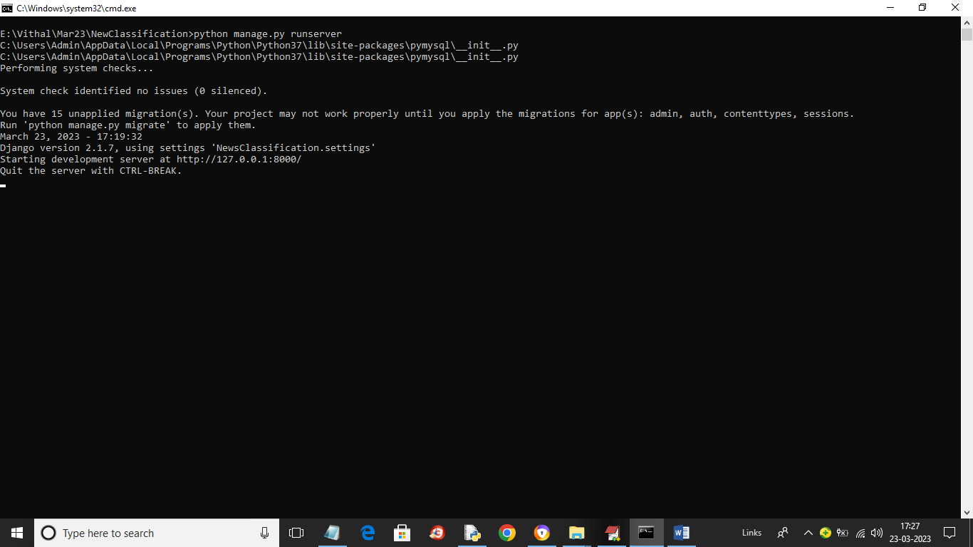
In above screen python server is started and now open browser and enter URL as http://127.0.0.1:8000/index.html and press enter key to get below page
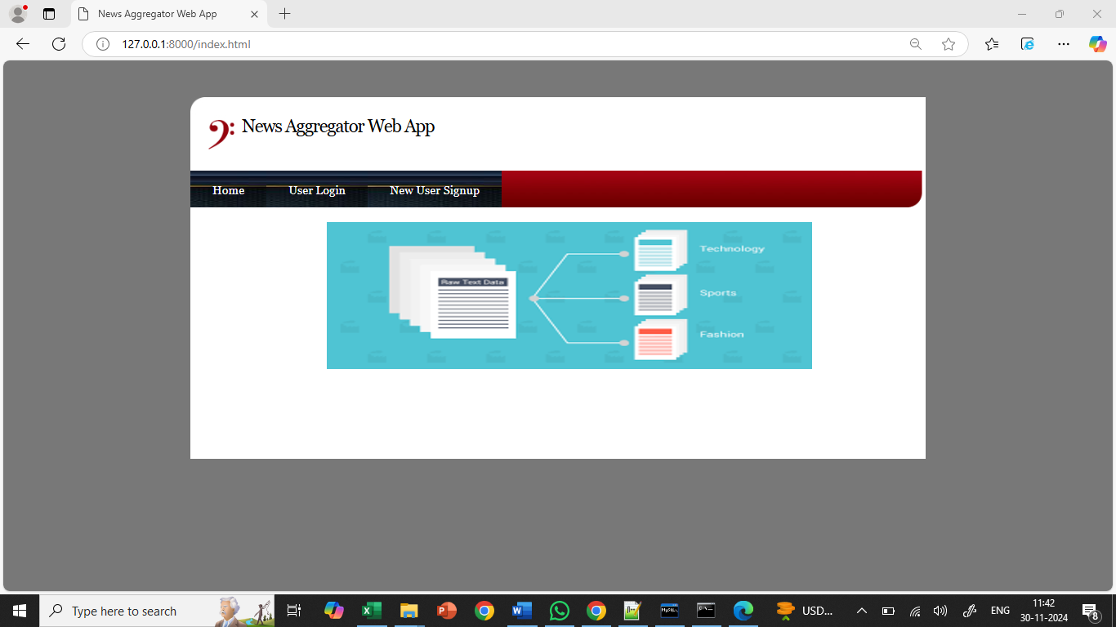
In above screen click on ‘New User Signup’ link to get below signup page
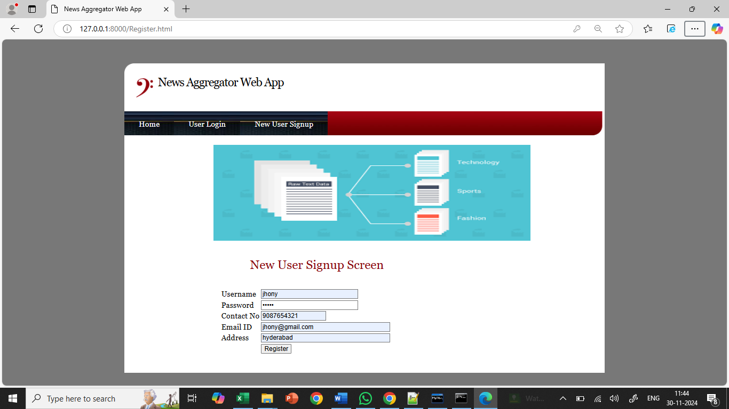
In above screen user is signing up and then press button to get below page
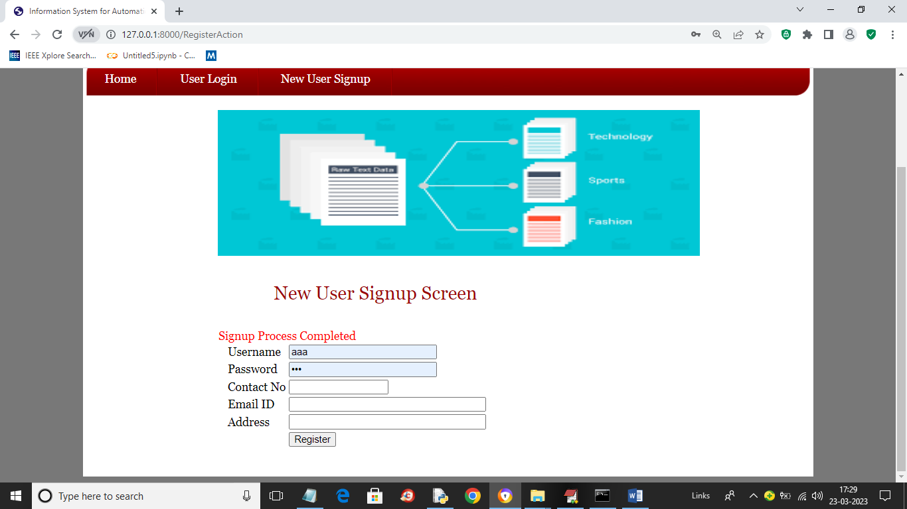
In above screen signup process completed and now click on ‘User Login’ link to get below login page
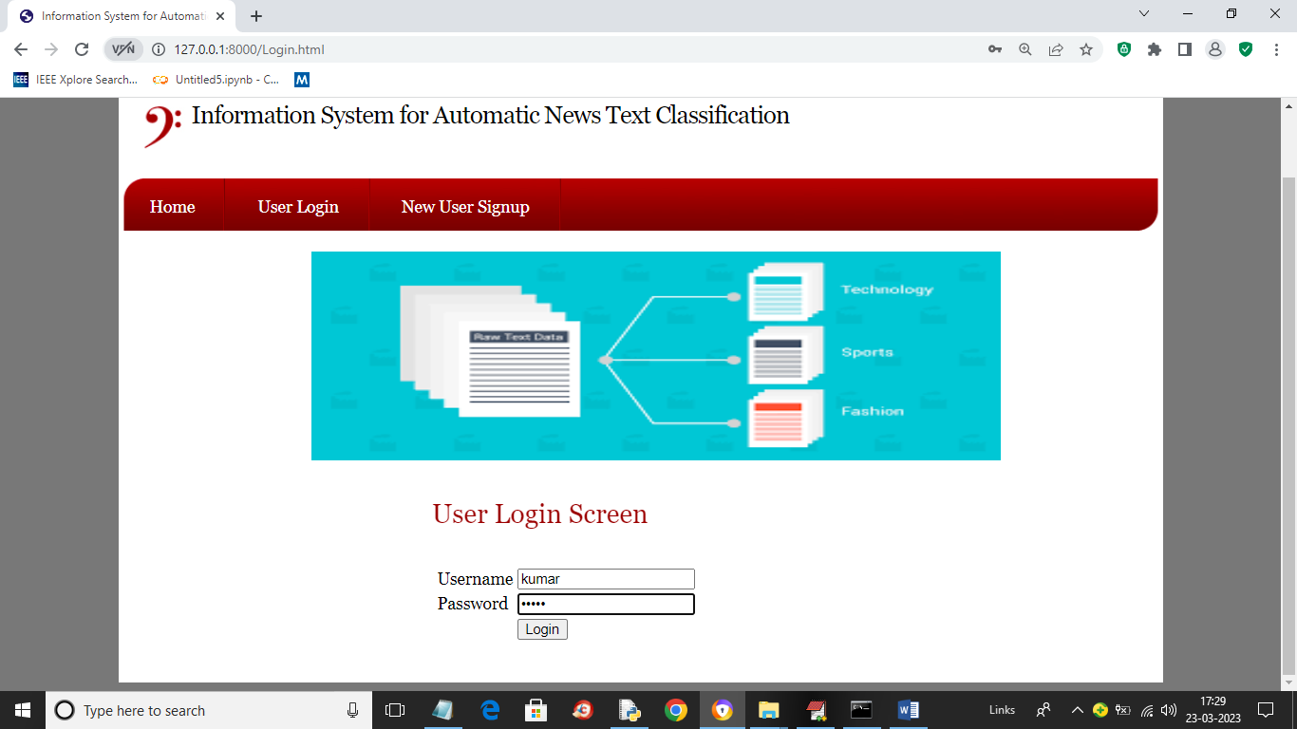
In above screen user is login and after login will get below page
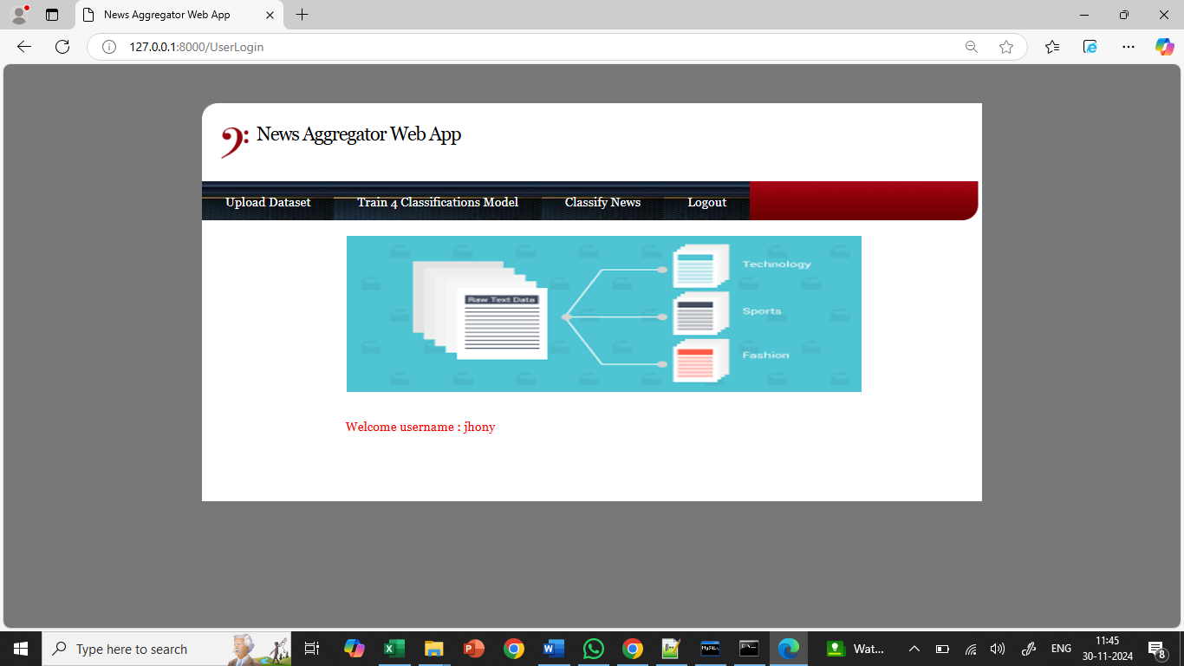
In above screen user can click on ‘Upload Dataset’ button to load dataset and get below output
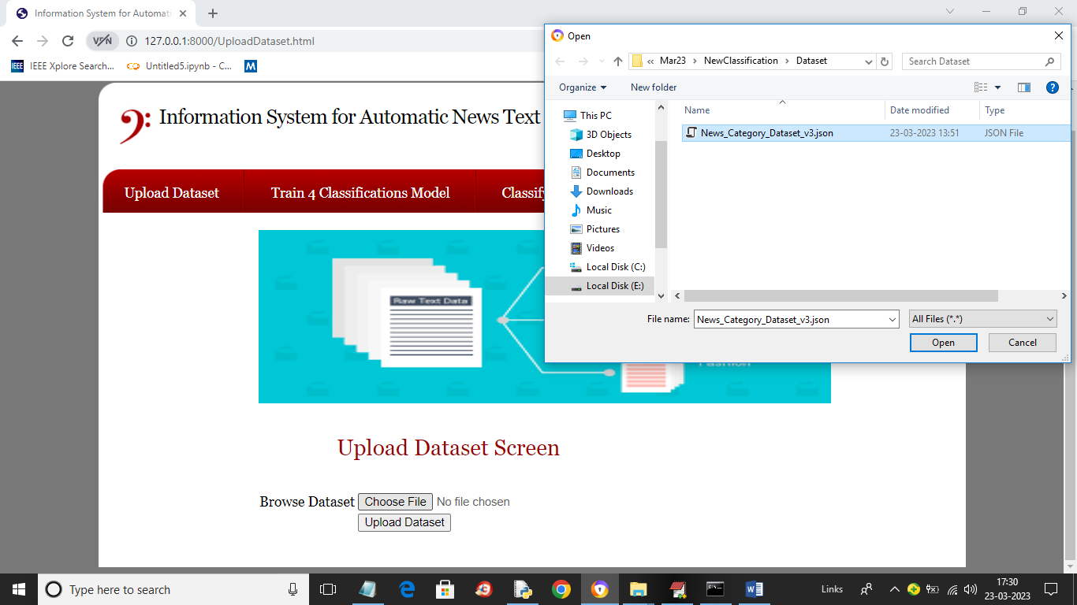
In above screen click on ‘Choose File’ button and upload dataset and this dataset you can find inside code under ‘Dataset’ folder and then click on ‘Open’ and ‘Upload Dataset’ link to load dataset and get below output
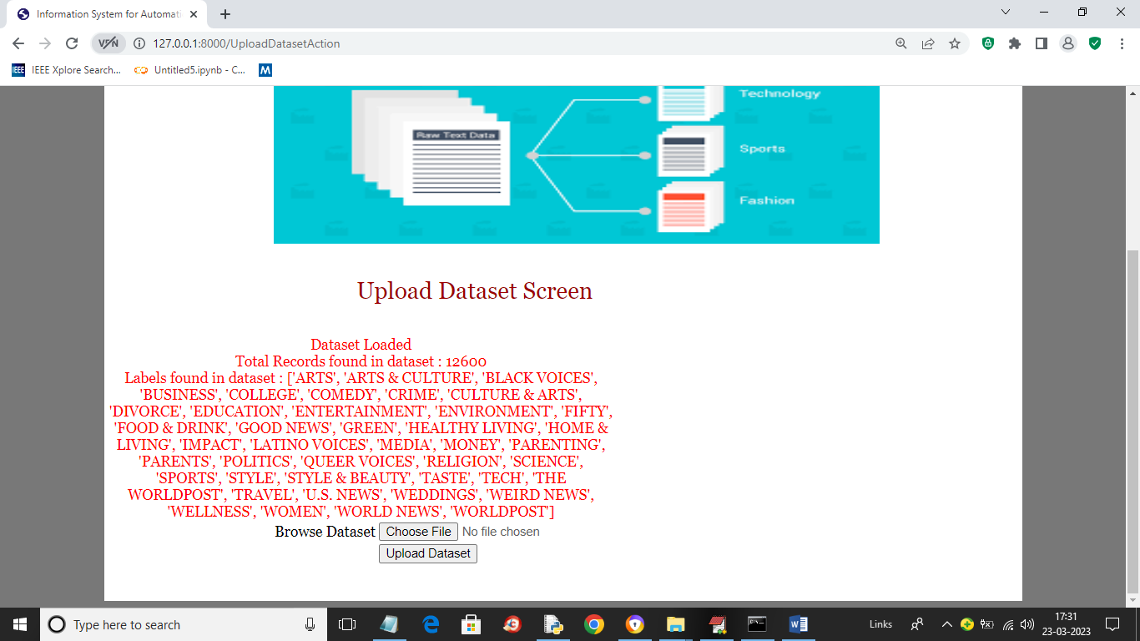
In above screen dataset loaded and in red colour text we can see dataset contains 12600 records and showing different news topics found in dataset and now click on ‘Train 4 Classifications Models’ link to get below output
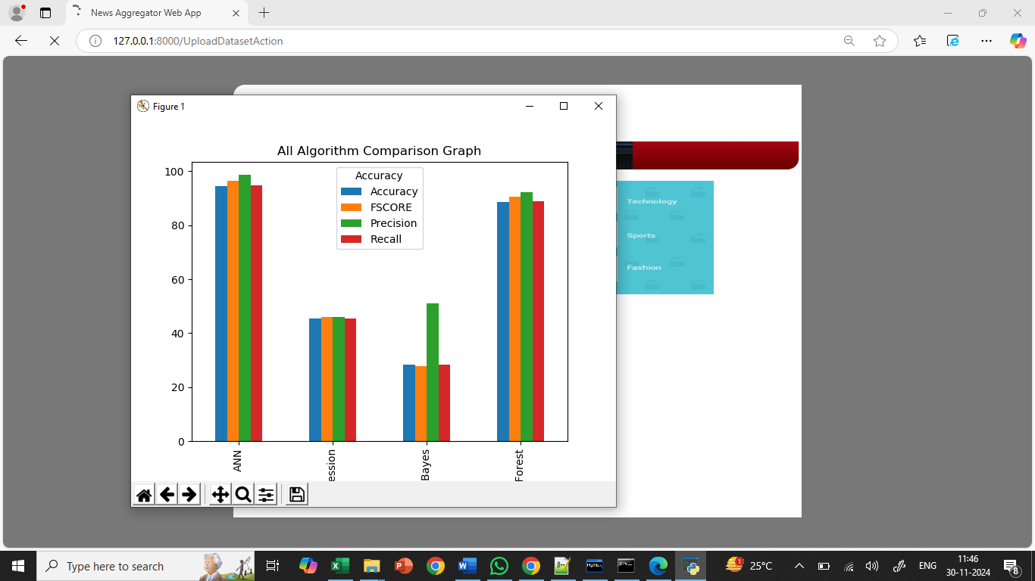
In above graph x-axis represents algorithm names and y-axis represents accuracy and other metrics in different colour bars and in all algorithms ANN got high accuracy and now close above graph to get below output
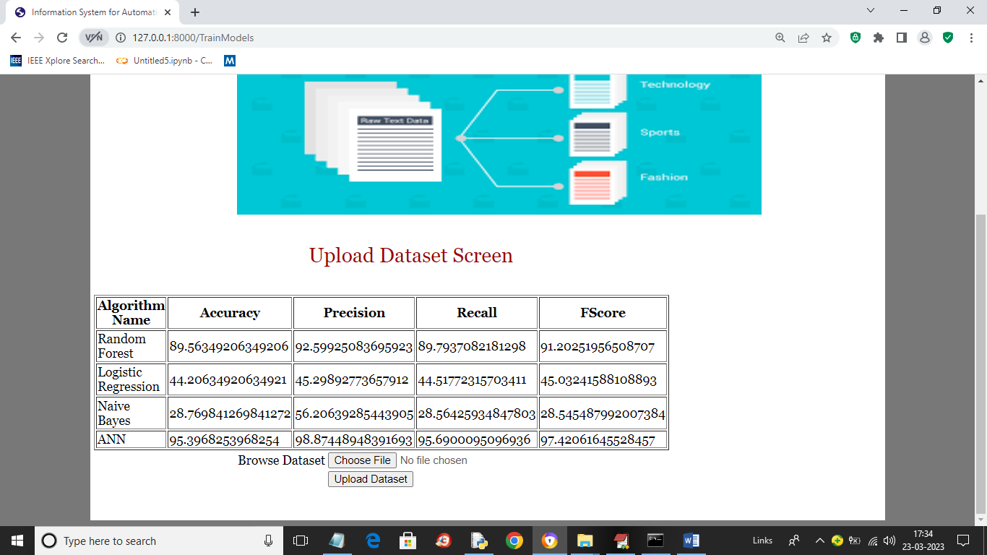
In above screen in tabular format we can see performance of each algorithm and we showing metrics like accuracy, precision, recall and FSCORE. Now click on ‘Classify News’ link to get below page
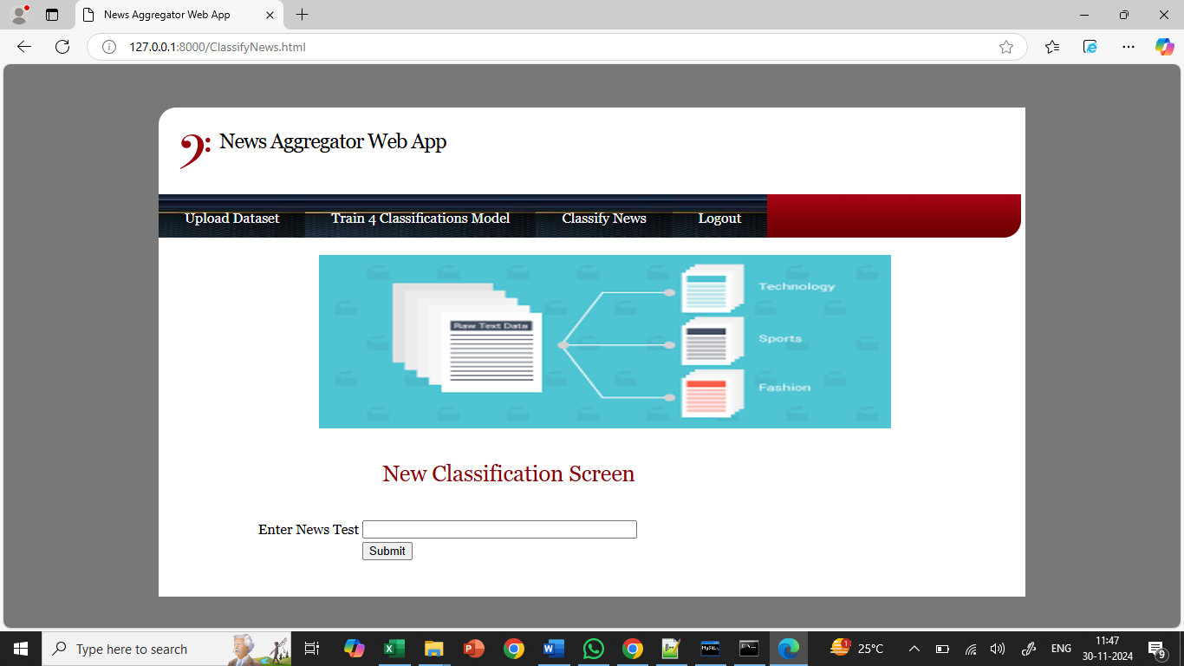
In above screen in text area entered some news or copy one line from ‘testNews.txt’ file (available in code folder) and paste in above field like below screen
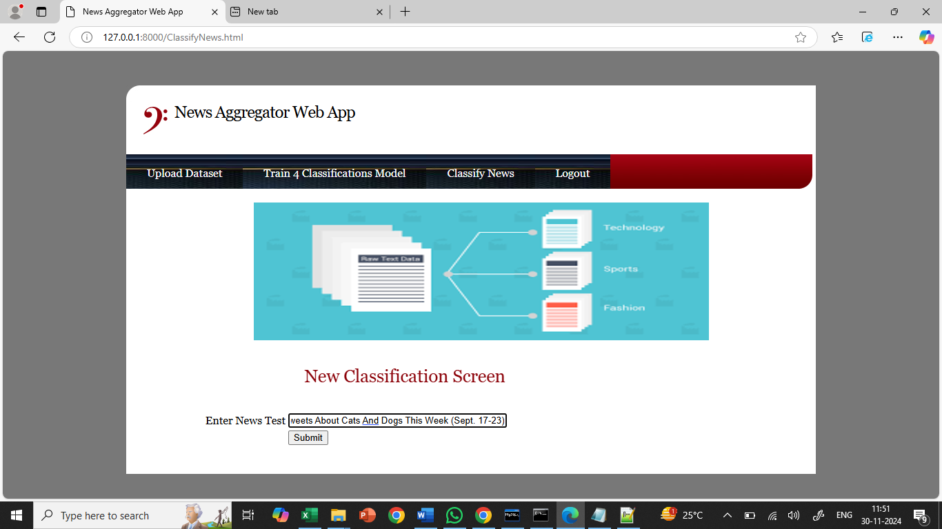
In above screen I entered some News Text and press ‘Submit’ button to get below page
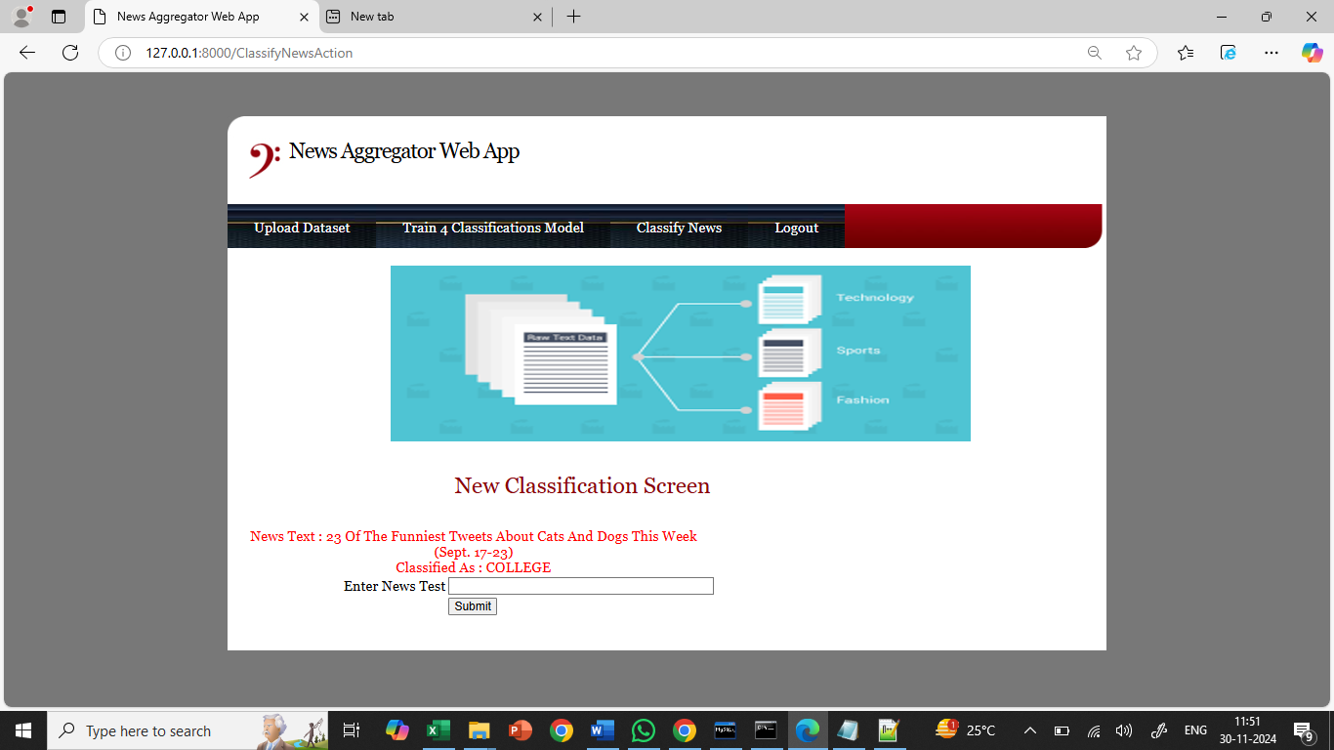
In above screen in red colour text displaying News Text and then in blue colour text you can News classified as ‘World News’. Similarly you can enter and classify news and below are the other output
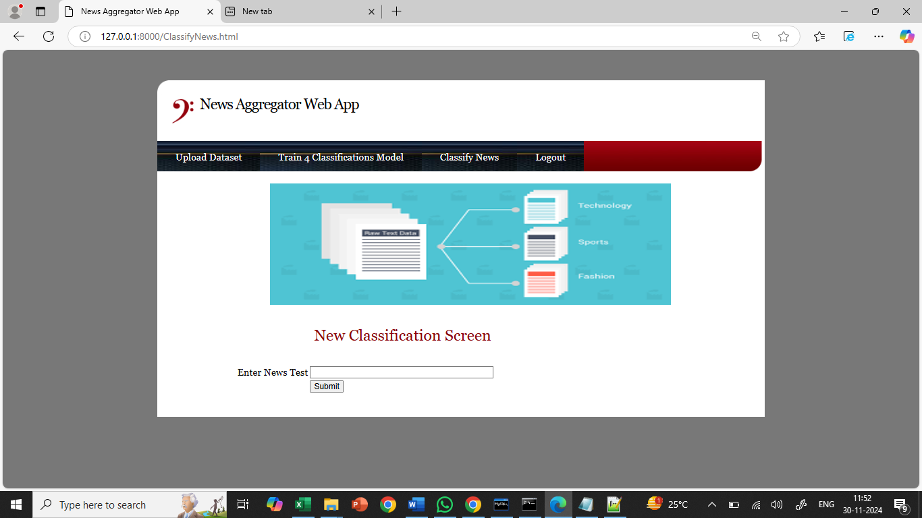
In above screen entered another news and below is the output
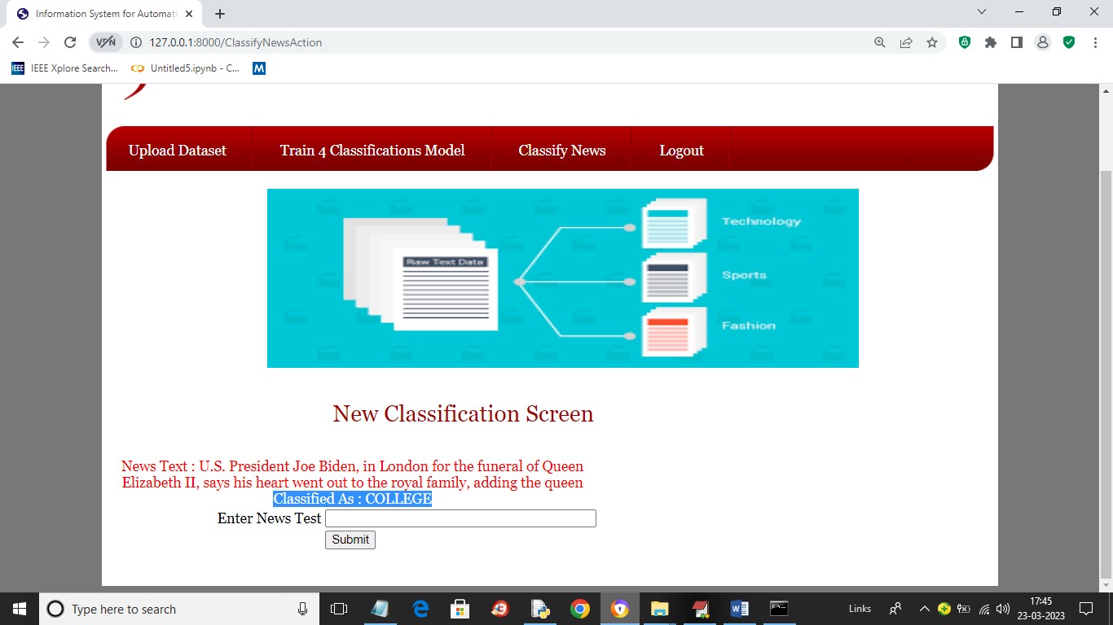
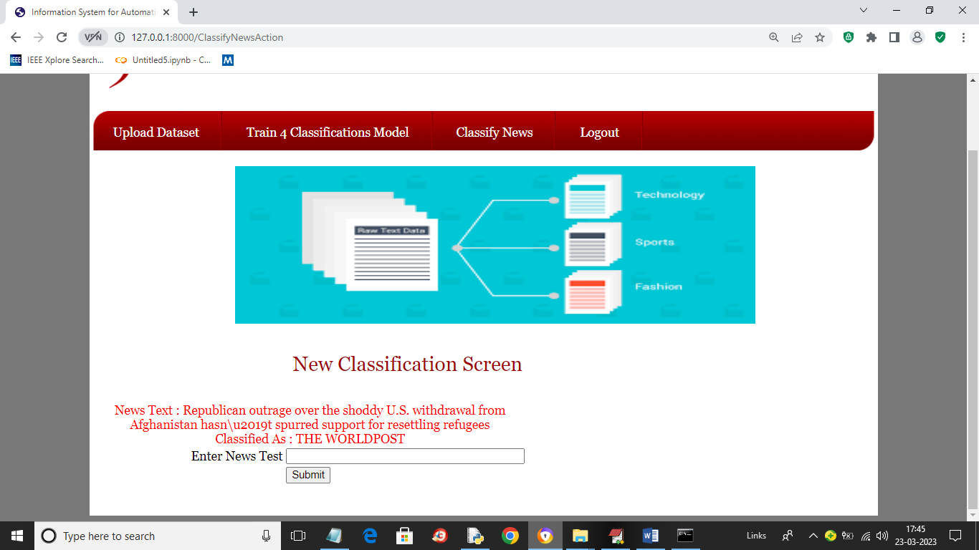
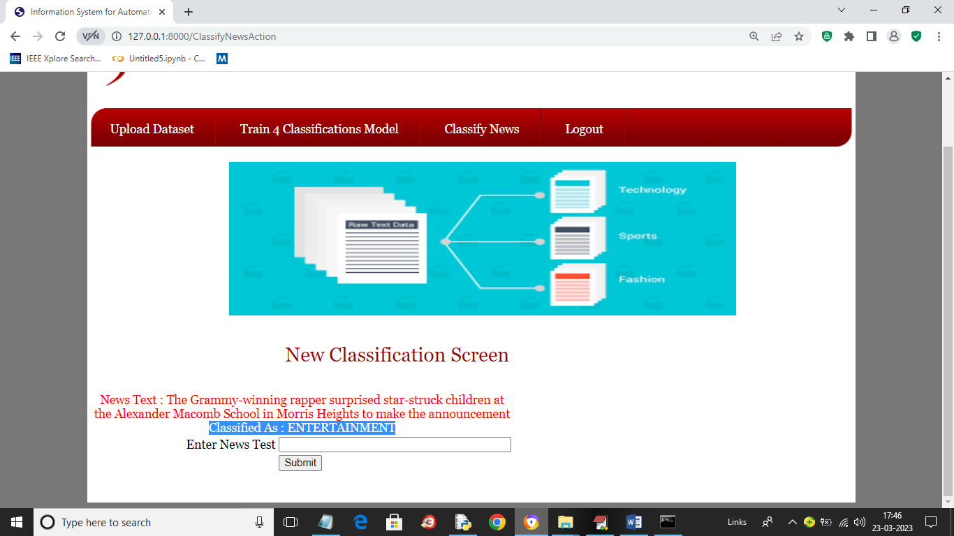
8.CONCLUSION:
The Information System for Automatic News Text Classification, a project of mine, provides a solid answer to the problem of effectively sorting news stories into forty distinct subject areas. Using ANN as the most effective model, I obtained higher prediction accuracy by using machine learning methods like Random Forest, Naïve Bayes, Logistic Regression, and others.
Signup for Users, Login for Users, Upload Datasets, Train Models, and Classify News are some of the user-friendly modules that reduce friction throughout. Registration is simple, users may load training datasets, and then they can use the system to categorize news stories. Data standardization, sanitation, and efficient splitting between training and testing sets are all provided by the system.

9.REFERENCES:
1.C. D. Manning, P. Raghavan and H. Schütze, "Introduction to Information Retrieval" in , Cambridge:Cambridge University Press, 2008.
Show in Context CrossRef Google Scholar
2.A. G. Shagraev, "Modification development and implementation of methods for classifying news texts" in Cand. tech. sci. diss, Moscow:MPEI Publ, 2014.
Show in Context Google Scholar
3.K. A. Yakil and N. Yu. Ryazanova, "SMS spam filtering", Automation. Modern technologies, vol. #9, pp. 19-24, 2016.
Show in Context Google Scholar
4.A. M. Tsytulsky, A. V. Ivannikov and I. S. Rogov, "NLP - processing of natural languages", StudNet, vol. 3, no. #6, pp. 467-475, 2020.
Show in Context Google Scholar
5.O. Harmatiy, "Features of news materials texts of news agencies", IV International Scientific and Practical Conference Stylistics: language speech and text, February 2017.

